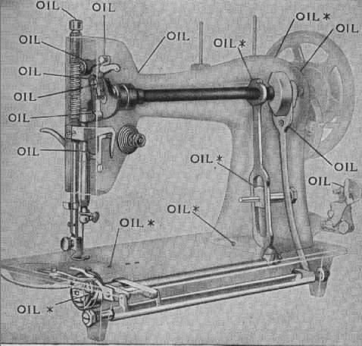

IV. MODEL 201

Come see my other sites

[ Gaileee's Featherweight Singer Sewing Machine Resource Site | New featherweight book | RARE Crinkle FW | Patchwork foot for FW | Huricane & Weather Site | John Wesley United Methodist Church ]
Need a manual or want to buy a 201? Please call my mom,
Deloris Pickens a call at (580) 765-6125. Please
tell them you heard about them from Gaileee's Internet Page...
thank you.... the webmaster.

---------------

Date: Fri, 27 Sep 1996 14:31:27 -0700
From: Judy Grow
Subject: model 15 and 201

Hi all,
More on the continuing saga. As you will recall DH came home with a
mystery black Singer in a table. Found out it is a model 15 made in
1932. Called my Sewing Machine Guy to ask if he would overhaul. He had
originally sent me on the trail of the elusive 201 and that's what DH
thought he was buying. SMG has a 201 in perfect condition which he will
sell me for $150.00. Says he will take the 15 in trade but suggests I
keep it for parts. The 201 will fit into the same table, so I am set.
He says the 201 is the BEST straight sewing machine ever made. Runs
quieter and smoother than anything else, and the straight stitch is
unexcelled. He says that few come on the market because most people who
sew for a living won't give them up. Anybody else out there with a 201
they can tell me about? I'm going to buy it tomorrow anyway.
Thanks. Judy in NJ
judygrow@blast.net

---------------

Date: Sun, 29 Sep 1996 09:18:47 -0700 (PDT)
From: "T.R. Kelley" trkelley@efn.org
Subject: TR? 101-201, first ZZ?

Frish Said:
> Hi everyone can someone explain to me what the difference is between the
> singer 101 and the singer 201

they both have geardrive motors on the back of the arm and top-loading bobbins,
but the 101 goes forward only, (big silver stitch length screw) the 201 has
reverse (stitch length lever) . there are a lot of other mechanical
differences,
but that's the main way to tell.
---------------

From: sharon@reese.org
Date: Tue, 1 Oct 1996 22:51:26 +0000
Subject: 201 and 66-14

This weekend I went looking for a cabinet for my 201 with AM serial # (it
cost $25), and I found a 66-14 with AJ serial # in a cabinet for $25. (My
best finds so far.)

The 66's cabinet has two small drawers on either side and looks like
a treadle cabinet with wood legs instead of metal. The 201's case
has beige fabric on the bottom and beige fabric and dark brown
leather on the top. I'm thinking of switching them and putting the
201 in the cabinet and the 66 in the case. I'm assuming that since both
machines were made in the 50's, a buyer could have have purchased
either machine either way, and it wouldn't look funny or hurt the
value of the machines for me to do this. I'd appreciate any feedback
or a description of cabinets people have that originally came with
their 201's.

Sharon
---------------

Date: Sat, 05 Oct 1996 23:01:10 -0400
From: Clay & Shelly Leihy clay-l@k2nesoft.com
Subject: Special (?) 201?

We recently got a 201 in gorgeous condition, save for lack of case or
cabinet, and it seems to be an unusual specimen. The serial# is
AF886558, born, according to Singer, in 1942. When I described it to our
sm mechanic, he was a bit surprised by the particular details,
especially the oval plate on top. This is in the same place as the
removeable plate on the FWs, with the spool pin on it. But, this one is
about 2" x 3/4", scrolled chrome, with two oil holes and a spool pin in
the middle. The plate is firmly fixed to the head, and the pin is
friction-fit. The mechanic showed us one he had, with the head being
solid up there (no plate) and a threaded spool pin. Our 201 has the
scrolled chrome round rear plate, FW-style scroll on the chrome
faceplate, blocky art-deco gold scroll on the bed, and a chrome-edged
handwheel. Also, I've read on the digest that the 201 is a 3/4 head --
This one is definitely full-sized! (As big and heavy as our 66-1). Do we
have some kind of wartime-industrial 201, or is this just a common
variation that we and our mechanic have never seen? And, what kind of
case or cabinet may this have originally come in?
---------------

Clay (& Shelly)
Date: Sun, 06 Oct 1996 11:01:35 -0700
From: Elaine Solomon madrona@teleport.com
Subject: Wheeler and Wilson #8 and Singer 128 "godzilla"_

snip

Wanted to respond to Clay and Shelly in regard to the 201 they acquired:
my 201 does have such a chrome oval on top, with the two oil holes and
the spool pin in the center. However, my faceplate is striated, as is
the round rear plate. My model is a Centennial-emblem one, in a cabinet
(the cabinet is rather plain, two drawers either side, wood drawer
pulls, with knee lever). The scrollwork is also the plainer variety.

snip

I "fixed" the smoking motor problem on my 201. I consulted Bobbie, who
told me to take it in to the shop. I don't have a reliable repair
person, the nearest shop wanted $100 to put the whole machine into a
degreaser bath. They said there would be additional charges if the motor
needed replacing. So I figured I could experiment. If the result was
that I'd ruined the motor, it wouldn't really cost me any more. Such
logic, yes? I took a can of an "Industrial Heavy Duty Degreaser", which
is mostly Trichloroethane (nasty toxic stuff) and sprayed the brushes
and the motor, tipping it and catching the runoff with old towelling. I
let the remainder evaporate, and tried the motor again. Success! No more
wisps of smoke. So I assume the problem was oil in the motor/brush
areas.

Elaine Solomon in Forest Grove, OR
madrona@teleport.com
---------------

Date: Sun, 6 Oct 1996 13:35:05 -0400
From: Rose525@aol.com
Subject: 201 problems

Hi! I wrote earlier but have never seen this in the digest. I guess my letter
got lost somewhere. I have a 201 I am having problems with it skipping
stitches. I don't have a manual yet and could someone give some suggestions.
Thanks, Rose525@aol.com
---------------

Date: Mon, 07 Oct 1996 19:57:13 -0400
From: Clay & Shelly Leihy clay-l@k2nesoft.com
Subject: Singer in NYT, motor cleaning, etc.

Motor Cleaning:
Someone mentioned a smoking motor on a 201, and described how she
cleaned it up to solve the problem. I have cleaned the contacts on a
couple of motors with great success. My solvent of choice is the old
motorcycle mechanics best friend, contact cleaner. Sprays right on,
dissolves all kinds of bad stuff, and evaporates completely when it's
done. You can find it at some automotive stores, and at Radio Shack, as
Cleaner/Degreaser. I would keep it away from the lacquer, as besides
Triclorotrifluorethane 76-13-1, Trichloromonofluoromethane 75-69-4, and
Carbon Dioxide 124-38-9, it contains Isopropanol 67-63-0 (rubbing
alcohol).

And thank you to all who replied about the 201 (especially T.R. Kelley,
who seems to know almost everything about old Singers). I think, judging
from the response, that our 201 is actually a pretty common style, and
that our SM mechanic hasn't had very much experience with this model. I
believe he mentioned once that he got into the business about the time
that the 401 came out, so his experience with older models is pretty
much limited to what people have brought in for repair or trade over the
years.

Clay (& Shelly)
http://www.k2nesoft.com/~clay-l/sewmain.html
---------------

Date: Mon, 7 Oct 1996 23:21:36 -0700 (PDT)
From: "T.R. Kelley" trkelley@efn.org
Subject: motor blocks, 201 needles, degreasing

Rose asked:
> Hi! I wrote earlier but have never seen this in the digest. I guess my letter
> got lost somewhere. I have a 201 I am having problems with it skipping
> stitches. I don't have a manual yet and could someone give some suggestions.

the needle in the 201 goes in with it's flat side to the left, and threads
right
to left. make sure you use a sharp new needle as well.

T.R. KELLEY
---------------

Date: Wed, 9 Oct 1996 18:49:27 -0400
From: Rose525@aol.com
Subject: 201 problems solved

I want to thank everyone who wrote to me with suggestions for my skipping
stitches on my 201 machine. I turned the needle flat side from right to left
and now it sews perfectly. Thanks to everyone and I knew you fanatics would
help me. Rose525@aol.com (Rosemary Beeler)

---------------

From: SWhita6apa@aol.com
Subject: Singer Advertising

The following is quoted from a 1951 Singer advertising brochure.

Machine Head No. 15-91 is a gear-driven electric of the oscellating shuttle
type, with round bobbin. A handy drop-feed device facilitates darning and
embroidery. Sews forward or backward with stitch perfection in either
direction.

Machine Head No. 66-18 is an oscellating sewing hook type with round bobbin.
It stitches material from light weight batistes up to heavy denims and
whipcords. It comes in a black "crinkle" finish. ( We now know what to call
the godzilla finish)

De Luxe Head No. 201-2 is a full rotary motion gear-driven electric with
horizontal rotating sewing hook. It is capable of unusually high speed and
will not lock. Thread tension and stitch length easily selected by number.

Machine Head No. 66-16 is of the oscellating sewing hook-type with round
bobbin and adjustable reverse feed for back tacking. Hinged presser foot
aids in sewing over pins and heavy seams.

The SINGER Featherweight Portable Model No. 221-1 outsells any other model in
the world. It weighs only 11 lbs., 1 0z., yet performs with the precision
for which SINGER Sewing Machines are noted. Operating with full rotary
motion, it forms a perfect lock-stitch in either forward or backward
direction.

Model No. 128-23 is a lockstitch, long bobbin-type electric portable, simple
to operate, and very dependable. The speed is regulated easily by foot
control. Comes with bentwood carrying case which locks onto its base.

Trim, compact, easy to collapse, occupying no more room than a card
table....the SINGER 3-way Table is the answer to women who want to save on
space and yet have the full advantages of an efficient sewing area. A
matching extension table, ideal for work requiring extra space, is also
available. ( Has any one seen one of these extensions?)

This advertisement also shows all of the cabinets available in 1951 including
the rare FW cabinet.
---------------

Date: Mon, 28 Oct 1996 21:45:50 -0700
From: MomofWeedy reyden@cadvision.com
Subject: walking foot for 301

snip
Re 201: I noticed reference a few days ago to a 201 being a gear-driven
machine. Mine is a 201-3 and is belt driven, not gear driven. It is a nice
machine, though. It is one machine that sits at the ready all the time for
a specific purpose.

Kathy in Calgary
reyden@cadvision.com
---------------

Date: Fri, 1 Nov 1996 20:19:46 -0500 (EST)
From: Lydia Pratt lspratt@freenet.columbus.oh.us
Subject: Problem FW and stuff

To James:
Checked out your 500/503 pages at work today, and also someone's 301
(yours, I think). Having the visuals available is really wonderful.
What's also neat is you can see more or less how the 201 evolved into the
301 and how the 301 evolved into the 401, etc. It's sort of like tracing
red hair or some other distinctive characteristic through your family tree.
Fun stuff!

Happy stitching to all!
_ _
Lydia Pratt |_|X|_|
Columbus, Ohio |X|*|X|
---------------

Date: Wed, 20 Nov 1996 10:50:30 -0800
From: Jesse Hargus sfjesse@pacbell.net
Subject: 201 help

Love the board, getting lots of great info and tips. Have a question,
I'm in desparate need of some kind of technical info on repairing
my 201. A tension problem I'm sure, putting the upper tension assembly
together is difficult for me, can't align the numbers right, and the
machine itself seems to have a very touchy tension adjustment, can't get
that perfect consistent stitch....any ideas? I'm faxable at 415-282-
2260, and emailable here, happy to pay for costs.
Thanks,
Jesse in San Francisco
---------------

Date: Fri, 29 Nov 1996 10:28:33 -0800 (PST)
From: Shannon Grant shanon@earthlink.net
Subject: bobbin mechanism

Hi All - I would like to know the differences, advantages & disadvantages of
the oscillating bobbin, shuttle bobbin, and rotary bobbin mechanisms. Is
there a reference book? My repair guy told me that the 201 comes is 2
versions: oscillating, and rotary bobbin, and that the oscillating type is a
real pain, and not to get one of those because it always is getting tangled
up. Only get the rotary type. True or false? I met a lady with a 201 rotary,
and it is WONDERFUL. TIA for any info you can impart. Shannon in San Diego
where it rained last night and they said it wouldn't.
---------------

Date: Sat, 30 Nov 1996 17:03:39 -0800 (PST)
From: "T.R. Kelley" trkelley@efn.org
Subject: shuttle, oscillator or rotary????

Shannon Grant wondered:
> My repair guy told me that the 201 comes is 2
>versions: oscillating, and rotary bobbin, and that the oscillating type is a
>real pain, and not to get one of those because it always is getting tangled
>up.

your repair guy is fulla beans! :) if it isn't full rotary it is NOT a 201.
period. top drop in oscillating bobbin machines are 66- class. oscillating
means
"back and forth".... tuen the handwheel and observe the bobbin area. if the
hook
travels in a complete circle it is a rotary.(221, 301, 401, 201, 500A, etc.) if
it moves back and forth it is an oscillator (15 and 66 class). a shuttle bobbin
looks like a long bullet. it moves back and forth. a rotary is the highest
speed
smoothest and quietest of the mechanisms. shuttle bobbin machines vibrate at
high speed. they were not designed to be operated at the high speeds associated
with electric motors and often portables often vibrate right off the table!

T.R. KELLEY
---------------

Date: Tue, 10 Dec 1996 14:50:49 -0500
From: Fred Zoback fzob@concentric.net
Subject: berninas

Hi everyone I just thought I'd throw in my 2 cents about berninas I was
lucky enough to get one about a month ago after being on a waiting list
for 2 years the best part was it was only 275.00 but I wanted to say that
their a great machine the way they sew is fantastic! to say the least. I
own 3 fw's , 3 201's , 3 99's , a 401A a 66-13 a sparton and needless to
say this bernina is like driving a Lincoln towncar. Don't get me wrong I
love all my singers and wouldn't part with any of them I'm just saying if
you get a chance to get a bernina at 450.00 thats a good buy. I'm still
stuck on singers though my favorite the 201's no question there they'll
sew through anything and the stitch is perfect!! Thanks for listening.
Frish in cold N.J.

---------------

Subject: SM near disaster!
Date: Wed, 22 Jan 97 17:42:27 -0000
From: TR Kelley trkelley@efn.org

Hi FOLKS

today i took a walk up to the closest goodwill, (resolving to get more
exercise). beautiful cold winter day, sunny. perfect! i got there just as
they were opening (9:30) and mindlessly riffled through the jeans and
such, but then figured hey! i'll just check and see about sewing
machines. nothing but the usual 5 or 6 old 60's imported boat anchors. i
check the furniture setion and yes! a cabinet! an austere-looking cabinet
with two drawers on each side, looking rather like a treadle stand. i
lifted the lid and inside was a centennial 201, condition 8+ i guess. all
gold "paperclip"-style decals and singer logos perfect, not rubbed in any
way. the machine is a little grimy but looks like it would clean up
wonderfully. in the drawers are a greist buttonholer, a mostly used old
tube of lube, all the attachments (no box) and in very very good
condition, the original manual. the flat rubber wiring's even good! the
only problem is that there's a HOLD FOR TINA tag on it, dated yesterday.
i march right up to the checkstand and say obviously Tina didn't come
back for it yesterday and i have the money right now and i want to buy
it! The guy checks with the manager who is more than happy to replace
HOLD with SOLD. i pay for the machine ($60! such a deal!) and practically
run home to get my car (two miles and i am overweight and out of shape).
i zoom back to the store. usually when i buy machine/cabinet combo's i
separate the head from the cabinet for easier and safer transport but
this machine is problematic it has a knee lever and the wire goes through
the little black iron flap at the right side of the machine opening.
there's no way to separate the machine from the cabinet, without cutting
or disconnecting the wire. it's original wire in good condition so i
don't want to cut it, and i don't have the time to disconnect the
terminal body and all that folderol (late to get my son from school!), so
i and an employee stand it in the back of my ford escort hatchback, i
cover it with my all-purpose Army blanket and reassure her that it's only
2 smooth miles to my house and it'll be fine. "nah don't bother tying
down the hatchback"
well the road is smooth all right, but i forgot about the hill and the
stoplight. i stop carefully on the incline, and when the light turns
green i step gently on the gas, and my top-heavy cabinet falls right out
the back of the car onto the pavement!!! i know you'll al understand just
how sick i felt! this is a busy intersection so i could not stop right
there and get it, i had to go through the intersection turn around and
come back, turn on the flashers and hope someone hadn't crashed into that
solid chunk of walnut & cast iron!
i got back to the scene, and it's still there, leggs sticking up in hte
air flat on it's top. there is a very large bearlike gentleman who
appears out of nowhere, scoops the whole thing up as if it weighs NOTHING
(80-90 lbs is my guess) and sticks it back into my hatchback, angled so
as not to fall again. i am speechless with thanks, and too flustered
about the heavy traffic to check out the damage.
i get it home and lift it carefully out of the car

~~~~~~~~~~T.R. KELLEY~~~~~~~~~~
---------------

Subject: continued story of dropped 201
Date: Wed, 22 Jan 97 18:02:31 -0000
From: TR Kelley trkelley@efn.org

CONTINUED SAGA OF THE 201(......the computer sent the message before i
was done or had a chance to check spelling and such!)

.....anyway i got it home to check for damage. the entire top leaf was
scarred pretty bad on the front edge and the metal of the hinges was torn
almost completely through. the motor housing had a bad dent. i want sure
if it was deep enough to impede the turning of the coils. i tried to turn
the hand wheel and it was jammed. oh great, i thought, i've cracked the
bed! but no actually the previous owner just hadn't reassembled the
bobbin case and hook ring correctly and the position finger was wrong
(similar to a FW, only on a different axis).
good thing i had removed the drawers and attachments before loading it
into my car or they wouldve been scattered and broken for sure. the
cabinet is not racked. in fact it's just as stable and sturdy as it ever
was, and aside from the horrid gouge on the front edge of the leaf, it
looks fine (good think i wrapped that old blanket around it i guess)
i plugged it in.......and it WORKS! it hums quietly and smoothly along,
it stitches like only a 201 can. it has obviously been well cared for
(heh! until I got ahold of it!). it had upholstery thread and a size 18
needle in it. i wonder if in clearing a thread jam and being unable to
get the bobbin case re-seated, someone just got frustrated and took it to
Goodwill?
so anyway, things are fine, i've gently punded out the dent in the motor
housing and touched it up with black paint. but i need some cabinet
hinges for the leaf, standard bronze-colored Singer with the three screw
holes in each half of the hinge. i have the screws, but my hinges are
unreparable, and i have no junk cabinets to scavenge hinges from
currently. can anyone help me out with this? i'll pay a fair price.
MORAL OF THE STORY: add to the list of things you need to go sm hunting
- a bungee cord or rope to tie your hatch shut with!! :)

~~~~~~~~~~T.R. KELLEY~~~~~~~~~~
---------------

Date: Sat, 25 Jan 1997 23:12:47 +1100 (EST)
From: Jake Jacobs mariners@netinfo.com.au
Subject: Handy Dad

I have a Singer 201 in a cabinet great condition the only thing wrong was
one missing handle the chances of getting a handle were slim to none. Dad
visiting at present has solved my problem . Took the original handle of
sawed it in two and I now have two handles that match and its all still
original . Lucky arn't I !Ann-Maree in Canberra

---------------

To T.R. Kelley-
Big applause for going public with your preference for the 201! This is
my favorite one at home-for machine quilting, *fast* and accurate piecing
(DW chides me continually for sewing too fast on it) and also for
heavy-duty work like leather. If they had made the 201 with an aluminum
casting, we might never have had a FeatherWeight list!
---------------

From: Chris Vagtborg 71155.1072@CompuServe.COM
Subject: post

Hello Again...

For Carolyn, re: 221 Service Manual - we have these plus mucho parts in
stock. Email me for the current list!

For Joan, re: 201. The 201 one is, in many people's mind, the best sewing
machine that Singer built. It is a rugged, quiet, full size (read, heavy)
machine that makes a perfect straight stitch. You won't be dissapointed if
you buy one...

>SINGER 201????
is not as common as a lot of other machines, but certainly not rare.
motor is built on, bobbin drops in to the right of needle, tension faces
operator. in Oregon i ususally find them for $25-$100. the are a
powerful, smooth, quiet sewing machine and i buy every one i find,
usually for later resale. i own two for actual sewing.
>
-
Converting Singer Sewing Machines from Electric to Treadle or Hand Crank
© 1998 Richard P. Wightman
(All rights reserved unless otherwise specified… may be downloaded for personal use, but may not be reproduced for distribution, sale or inclusion in any other published work without the express written consent of the author)

Sewing machine collectors, and especially those with an interest in actually using the older machines, often find themselves in possession of machines that have been converted from treadle to electric, or they may have a nice treadle that has had it's machine removed. Possibly they have a treadle that's nice, but the machine in it is badly worn or damaged. Any of these situations can indicate the desirability of finding a better head and/or converting some Singer head back to treadle, or possibly to hand crank. These pages should enable you to carry out this conversion in most instances.
First, machines older than the Model 66 are rarely found in original electric installations. The vast majority of Model VS #2, 27, and 127 machines were treadles or hand cranks to start with, and if found with motors, were almost always something that was converted after original sale. These models do not have the cast on motor boss at the right side of the pillar, which later became standard on all Singers until the modern castings for internal motors were introduced in the late 1950's. Conversion of these machines back to treadle status is usually extremely simple. The original conversion to electricity generally involved the drilling and tapping of screw holes on the machine to attach a motor and or light. Remove the motor and/or light and put the head in a treadle cabinet. That's it. Conversion to hand crank is more difficult, as the hand crank used on these older machines was one that mounted on the wood base of the portable case. Usually, this is long gone. The modern hand crank available today is designed to attach to the standard motor boss, and cannot readily be attached to these older models that don't have that boss.
A word about hand wheels… there are two varieties of standard Singer hand wheel. These are the spoked wheel, common to the older heads that were designed for treadles, and the solid wheel, used for the somewhat later machines when an electric motor was the original installation. There are two differences in these wheels. The spoked wheel is 4 ounces, or 20%, heavier. This gives it a little better momentum for smoother, easier treadling. It is also somewhat larger in diameter, and the outside edge is thicker. This makes hand contact, which is a standard element of treadling, easier. However, in converting an electric to treadle, it is not an absolute necessity that the hand wheel be changed. The electric style, solid hand wheel will work quite well in a treadle if you don't happen to have access to a spoked wheel. Bear this in mind when using the following instructions.
Following will be first a brief narrative outline of the conversion procedure, then a step by step description, with pictures, of the conversion process. Two machines are shown… a Model 66-19 and a Model 99. The conversion process is essentially the same for both, except that the 99 requires some additional work to accommodate the bobbin winder to the smaller inside diameter of the spoked wheel used. Again, remember, you don't have to change to the spoked wheel. If you retain the solid wheel, no adjustment to the bobbin winder is necessary.
Two other models should be mentioned… the 15-88/89/90 and the 201K. The 15-88/89/90 are all the same machine. The only difference is the motive power. The 88 was the designation for treadles, 89 was for hand cranks, and 90 was for electrics. The 88 and 89 had the spoked wheel. These are frequently encountered converted to electric, but with the spoked wheel still in place. The 90 had the solid wheel. This machine is more common than the other two. Until I discovered the 201K, this model series was my favorite treadle machine. It is a real workhorse, and offers both reverse and lowering feed dogs. If you find one of these heads, don't pass it up.
Singer's Model 201 is often credited as the best sewing machine ever built, certainly it is the best Singer ever built. However, the most common U.S. version is an internal motor machine and is not readily convertible to treadle. However, due to late rural electrification in Europe, the British Model 201, the 201K, was made without the internal motor, and was offered in treadle, hand crank, and electric with external motor and belt drive. Many of these were imported into the US after production of the U.S. version stopped. Many others came in by way of Canada. There are also a few U.S. produced external motor machines, though these appear to be much less common. In any event, all of these machines will fit in a standard Singer treadle and if you can find one you will have the best treadle machine available, in my opinion.
Note: conversion of either the Model 15 or the Model 201 will involve bobbin winder adjustment as described for the Model 99 below.

Steps in Converting from Electric to Treadle or Crank:
- Remove motor and light... belt will stay on machine.
- Back set screw out of clutch release wheel and remove clutch release wheel.
- Remove clutch control washer (three eared washer behind clutch release wheel).
- Remove hand wheel.
- Remove belt and if bobbin winder tire is worn, replace it with a new one.
- Replace solid style hand wheel with spoked hand wheel if available, if not, replace original hand wheel.
- Replace clutch control washer and clutch release wheel
- Screw in set screw in clutch release wheel and check adjustment of clutch. If it does not release fully in the release position or engage fully in the engaged position, remove the clutch release wheel and rotate the control washer. Reassemble and check again.
- Check function of bobbin winder. If spoked wheel was used to replace solid wheel, on some models the bobbin winder tire will not have sufficient adjustment to contact the hand wheel for bobbin winding.
- If the above situation exists, remove bobbin winder adjustment screw. Bobbins can be wound by using finger pressure to press bobbin winder against wheel. This is the standard system on some Singer models in any event. If desired, the adjustment slot in the bobbin winder assembly can be opened up (see pictures below) to allow a greater range of adjustment.

At this point, you are ready to place the head in a treadle. If hand crank operation is desired, either an original or reproduction crank can be used. The crank is attached to the motor mount boss with one screw, just as the motor mount was. CAUTION: The screw used to mount the motor and the screw used to mount the crank are not the same length. The motor mount screw is too short to firmly attach the crank. The new cranks come with a new screw. DO NOT attempt to use this screw if re-attaching the motor. It is too long, will bottom out in the threads and can break off, leaving you unable to mount either the motor or the crank. If you have an old crank and no screw, you will have to find a correct screw at a hardware or sewing machine repair outlet.

Pictorial Review of Conversion of Model 66-19
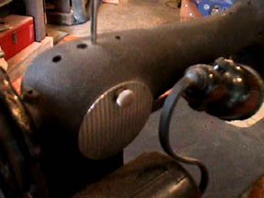  Here is the back of a 66-19, showing the light, attached to a metal bracket that is in turn attached to the machine behind the silver access plate. | 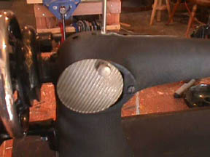  The access plate was swung aside, the metal bracket and light removed, and the screw that held the bracket replace in it's hole so it won't be lost.
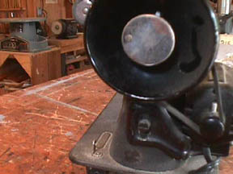  Here you see the right end of a Model 66-19, where our work will be done. Note the motor mount below the hand wheel, one screw holding it on. If you look closely, you can also see the set screw at 9:00 o'clock in the silver clutch release wheel. | 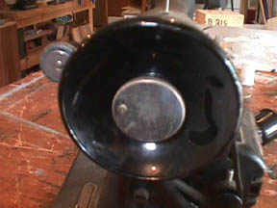  Here the set screw in the clutch release wheel has been backed out enough to unscrew the wheel.
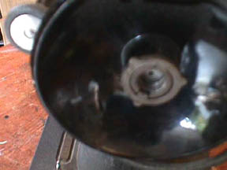  Clutch wheel has been removed, revealing the clutch release wheel control washer. This washer has three ears, which are not evenly spaced… these provide the adjustment for the clutch wheel, which will come into play later. Note how this washer is mounted so you can get it back in properly. | 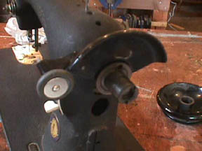  Handwheel has been removed, revealing the shaft and also allowing clear access to the bobbin winder tire. The motor belt should have come off with the hand wheel. Note that we have been dealing with the solid, or electric machine, style hand wheel.
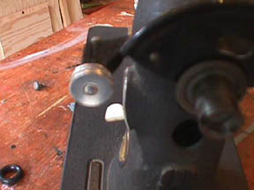  Bobbin winder tire has been removed (just pressure it off sideways). New bobbin tire can be seen to lower left. | 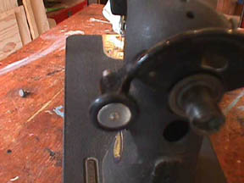  New bobbin winder tire in place.

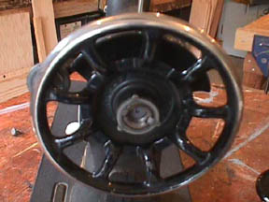  Spoked hand wheel has been placed on shaft. Put a drop of oil on the inside of the wheel before putting it on. Control washer is also back in place, ready to screw clutch wheel back in.. | No picture here… just discussion of clutch wheel adjustment. The little set screw in the clutch wheel, when screwed in, sticks out in back and bumps against the ears on the control washer. This controls the clutch adjustment. When you have the clutch wheel installed and the set screw in, test the adjustment range. Tighten the clutch wheel… does it tighten down so that the needle bar moves when the hand wheel is moved. When the clutch wheel is loosened, does the hand wheel spin freely without moving the needle bar? If so, then the adjustment is correct. If not, remove the clutch wheel and rotate the control washer, then re-install the clutch wheel and try again until you have found the position that is correct. It is often easiest to install and uninstall the clutch wheel if you stand the machine on end, as the washer tends to fall out of place as you try to put the wheel back in.

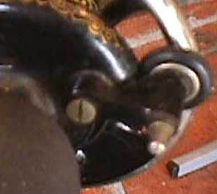 | To the right, you see the bobbin winder on 66-19. No problems here. This model has a bobbin winder that is very simple. The bobbin is slipped on pin opposite tire and the whole assembly simply pivots on the silver screw to the left. It is designed so that you just hold it so that the tire rubs against the hand wheel until the bobbin is full. You are the control mechanism. This bobbin winder has sufficient adjustment that it works with either style of hand wheel.

At this point, you have completed conversion of the Model 66 to treadle. If you are converting to hand crank, you will find the next pictures helpful:
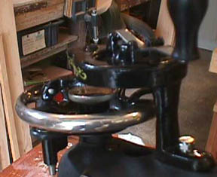  Machine is stood on end and hand crank has been mounted on the motor boss. Note that a new screw, silver as opposed to the old one which was black, is used. As noted above, you cannot use the motor mounting screw for the hand crank or vice versa. | If you look very closely at the picture to the right, you can see, at about 8 o'clock on the wheel, the rubber finger of the crank engaged in the wheel spokes. This finger has a pivot, and can be flipped up to disengage the wheel. This means that you can mount the crank on a machine in a treadle cabinet, release the treadle belt and use the hand crank, or disengage the hand crank, replace the belt and treadle. You need not remove the hand crank.
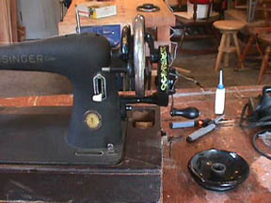
Here is a final picture that throws one more caution at you… the hand crank, when installed, will prevent the machine from fitting into a modern portable case. While the handle will flip up, reducing the length, it is not sufficient gain to enable you to put the lid on the base.

Additional Information for Conversion of Models 99, 15 and 201K. (Model 99 Shown)
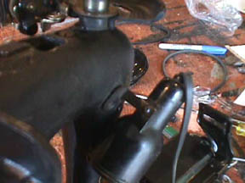  On the Model 99, the light is screwed directly into the casting of the machine. The mounting screw cannot be reached directly with a screwdriver, the light is in the way. Here, the machine has been stood on end, showing the bottom of the light. Remove the screw from the light itself. This will permit access to the screw fastening the bracket to the machine | 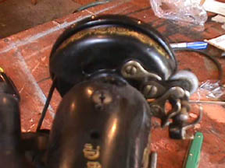  Bobbin assembly on 99 is much more complex. It has the automatic release when full mechanism. If you changed to the spoked wheel, this will no longer work. (Note that you don't HAVE to change hand wheels.) If you are changing wheels, which I personally do prefer, then follow the steps in the next pictures.
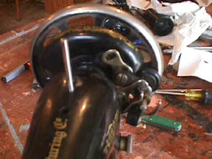  The simplest way to handle the bobbin winder problem is just to remove the screw that controls the adjustment. Here you see that that screw has been removed. You can now press the bobbin winder down far enough to hold the tire against the spoked wheel… releasing the pressure when the bobbin is full. Essentially the same system as on the Model 66 above. | Discussion time again.. In many past cases, I have handled the bobbin winder adjustment problem and retained the automatic release feature by sawing or filing out the end of the adjustment slot to permit a greater range of movement. If you wish to do this, keep on going…
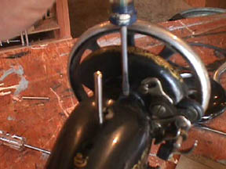  The easiest way t get at the bobbin assembly is to remove the whole belt guard piece it is mounted on. Here you see screwdriver removing the single screw that holds the guard on. Be careful with the actual bobbin assembly when you remove it from the guard. The central pin screw is spring mounted… don't let the whole works come undone! | 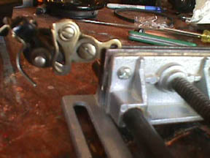  Bobbin winder assembly clamped in portable vise (a must have tool!), ready to have end of slot hack sawed and filed out.
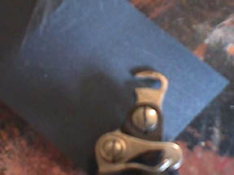  Slot with end cut out. Note that the curve of the bottom edge has been carried out. This is necessary to get the needed adjustment. | 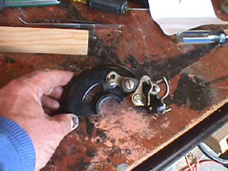  Assembly put back on the belt guard plate. Obviously, the final step is to replace this assembly and adjust the bobbin winder. In this particular case, there almost wasn't enough room to get the needed adjustment. I ended up with very little screw surface bearing on the slot piece… but it worked.

That's all folks… put the 99 in a treadle or attach a hand crank as above, and have fun.

Hope you have been able to follow all of this, and that it helps you to save a machine or two for treadling.

Dick Wightman

Singer Model 201: Lowering the Feed Dogs
Darning or Embroidering
When darning with fine thread, the use of Darning Foot 121094 is recommended.
This darning foot can be purchased at any Singer shop or from any Singer salesman.
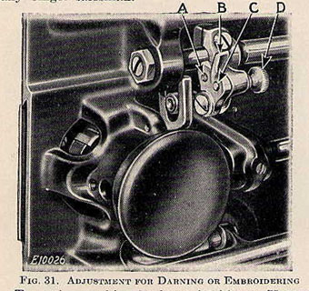
Turn the machine back on its hinges. Unscrew the thumb screw (D, Fig. 31), which is located in the lower
hole (C) in the feed lifting crank (B). Move the feed lifting crank (B) down so that the
thumb screw (D) will enter the upper hole (A). Having inserted the screw in this hole, tighten it firmly.
The feed is thus rendered inoperative and will not interfere with the free movement of the work.
Bring the machine forward into place.
Move the stitch length regulator lever to its neutral position at the center of the slot.
Remove the presser foot and let down the presser bar lifter to restore the tension on the needle thread
which is released when the lifter is raised.
Draw up the bobbin thread as for regular sewing.
When darning flat work, it is advisable to use embroidery hoops to hold the work.
Place the work in the machine, having the unworn part near the hole under the needle. Commence the
darning by making a line of stitches across the hole and a little longer than the width of the hole. Continue
making parallel lines of stitches across the hole, moving the work backward and forward and at the same
time gradually moving the work sidewise until the hole is covered with lines of stitches running across the
hole. Then commence as before and move the work lengthwise of the hole until the stitches across the hole
are completely covered and the darn is finished.
When you have finished the darning or embroidery, raise the presser bar lifter and replace the presser foot.
Turn the machine back on its hinges and replace and firmly tighten the thumb screw (D) in the lower hole (C)
in the feed lifting crank (B) as shown in Fig. 31. Bring the machine forward into place and it is ready for regular sewing.
Stockings and socks, underwear, etc., can be more conveniently darned on the machine with the Singer Darner
which can be purchased at any Singer shop or from any Singer salesman.
Instructions for embroidery are contained in the "Singer Instructions for Art Embroidery" sold by Singer
Sewing Machine Company at a reasonable price.
Advantages of Machine 201-2 for Darning or Embroidery
In practically all earlier types of sewing machines if the stitching is reversed, as in darning or embroidery, a
knot is formed on the underthread at each stitch, resulting in a poor appearance of the underside of the
embroidery or darn. The 201 machine and other late designs of Singer machines are free from this defect.

Singer 201: Threading the Bobbin Case

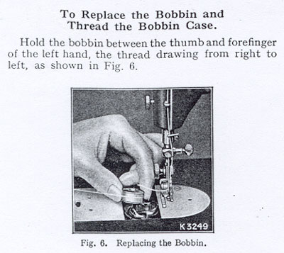

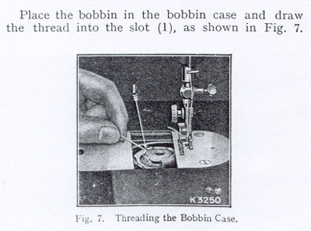

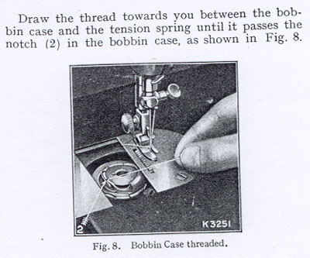

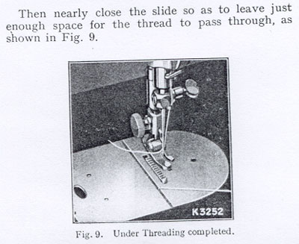

Class 201

Cabinets for Class 201 Machines
 | 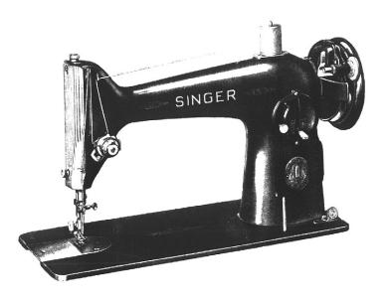
  Class 201
  Low Shank
  Rotary Hook
  Class 66 Bobbin
  15x1 Needle
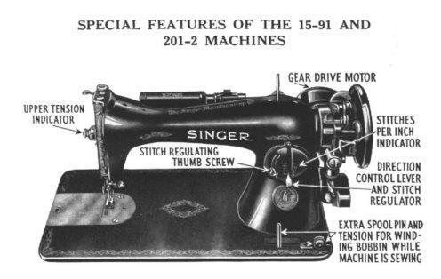
Electric 201K
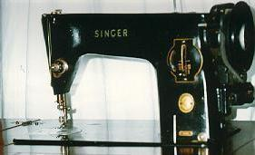
(Picture Courtesy of Sarah Brown)
Centennial 201
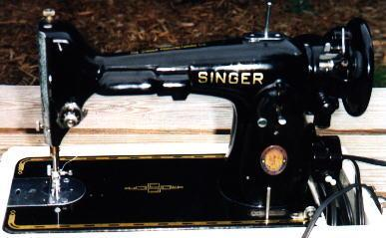
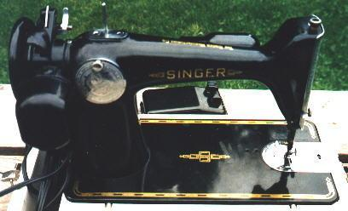

No. 47 Cabinet

15-91's
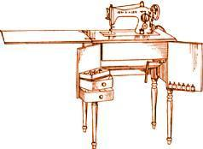
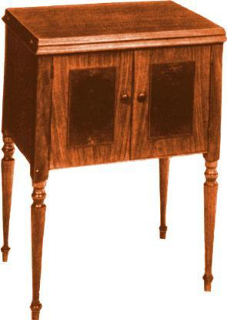
Tasteful lines and burled panels give no hint of the sewing machine enclosed within. Convenient drawers hold the box of attachments and supplies, while spools are placed on pins provided for that purpose. This cabinet also shows its versatility by becoming, when closed, a fine piece of furniture. This cabinet shipped with the 15-91 machine.

