TO POSITION HOOK TO OR FROM NEEDLE
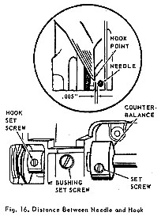 | CHECK:  Remove throat plate and turn hand wheel over toward operator until lower timing mark on needle bar is at lower edge of needle bar bushing on its upward stroke. With needle bar in this position, the distance between the side of needle and point of hook, as shown in insert in Fig. 16, should be .005". This is approximately the thickness of a piece of ordinary note paper.  SETTING:  Loosen counterbalance set screw, Fig. 16, and move counterbalance away from bushing. Loosen one hook set screw. Turn balance wheel toward operator to position needle bar as instructed above. Loosen the other hook set screw and bushing set screw. Using a 1/4" brass drift pin, gently tap bushing to left or right as required. Press hook assembly against bushing and tighten hook and bushing set screws. Re-check setting and replace counterbalance with hub against bushing.

TO TIME THE HOOK
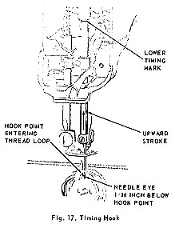 | PREPARATION:  Set needle bar height and position of hook to or from needle as previously instructed.  CHECK:  With needle threaded, turn hand wheel over toward operator until needle bar reaches lowest point and rises to position where lower timing mark on needle bar, Fig. 17, is just visible at lower edge of needle bar bushing. With needle bar in this position, the point of the hook should be approximately 1/16" above the needle eye and entering the needle thread loop.  SETTING:  Remove bottom cover. Loosen rotating hook shaft pulley set screws, Fig. 18, or hook shaft bevel gear set screws in gear driven machines. Turn shaft manually until point of hook is in its correct position to the needle eye and needle thread loop, as shown in Fig. 17. While holding hook in this position, tighten

