TO POSITION FEED DOG (continued)

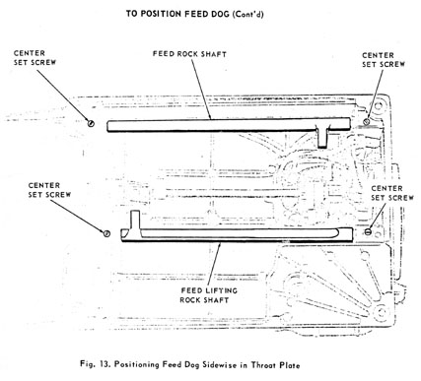
Sidewise Setting
PREPARATION:  Set feed dog height as previously instructed.  CHECK:  Feed dog should be centrally located between the sides of the feed slots of the throat plate.  SETTING:  Loosen the four center set screws, Fig. 13, holding the feed rock shaft and feed lifting rock shaft | centers in place. To move feed dog toward the left, gently tap the right hand center of the feed rock shaft and feed lifting rock shaft to the left until feed dog is correctly positioned. Then tighten the four set screws. To move feed dog toward the right, gently tap the left hand centers to the right until feed dog is correctly positioned.  NOTE:  Check for end play or binding in feed rock shaft and feed lifting rock shaft. To adjust, loosen center set screw at right end of machine and move center as required.

