SETTING:  Loosen hinge nut on FEED LIFTING ROCK SHAFT, Fig. 12, and turn eccentric hinge screw until high point of eccentric is toward rotary hook shaft. Then turn eccentric hinge screw as required to correct height.  .  Maintain this setting while tightening hinge nut. | 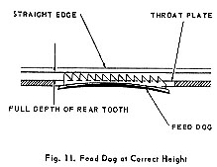
TO POSITION FEED DOG IN THROAT PLATE SLOTS
LENGTHWISE SETTING  PREPARATION:  Set feed dog height as previously instructed.  CHECK:  Feed dog should move as close as possible to front of throat plate slots without striking throat plate. | SETTING:  Loosen hinge nut on FEED ROCK SHAFT, Fig. 12, and turn eccentric hinge screw until high point of eccentric is away from rotary hook shaft. Then turn eccentric screw as required to bring feed dog in correct position.  Maintain this setting while tightening hinge nut.
