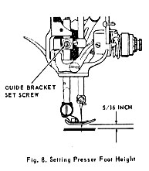 | 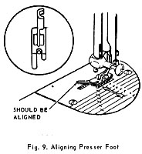
TO SET THE PRESSER FOOT HEIGHT
CHECK:  When presser foot is raised to highest point, distance between bottom of presser foot and top surface of throat plate should be 5/16 inch, as shown in Fig. 8. (Note: The needle clamp, when at its lowest paint, should not strike the raised presser foot.)  Presser foot should be in alignment with throat plate slots and feed dog, as shown in Fig. 9. Inset, Fig. 9, shows correct alignment of presser foot with needle. | SETTING:  Loosen guide bracket set screw shown in Fig. 8 and raise or lower presser bar as required to obtain correct height.  Align presser foot with throat plate slots and needle as shown in Fig. 9.  Securely tighten guide bracket set screw.
TO SET THE FEED DOG HEIGHT
PREPARATION:  1. Remove bottom cover.  2. Set stitch length regulator for 12 to 15 inches per inch.  3. Turn hand wheel toward operator until feed dog is in its highest position. | 