Lubrication

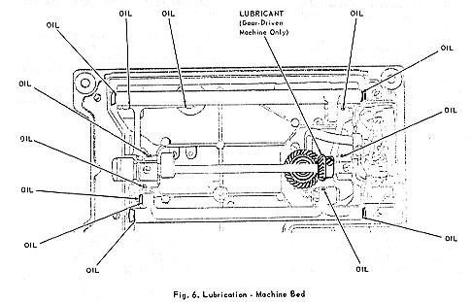
TO LUBRICATE THE MOTOR  Never use oil or ordinary gear grease to lubricate motor. Entrance of oil into motor may cause failure of electrical components.  Use MOTOR LUBRICANT sold by The Singer Company.  The two motor grease tubes, Fig. 7, should be refilled every 6 to 12 months, depending on machine usage. | 