Featherweight Service Manual
The manual is split into multiple parts. Pictures are the original but the type has been reset for clarity. This was intended for trained engineers – only take on jobs with which you are comfortable.
PREPARATION FOR INSPECTION
Before inspection to find causes of faulty operation, the machine should be thoroughly cleaned and lubricated.  Remove face plate and throat plate. Open arm top cover and remove bottom cover.  Remove lint and other foreign matter that may have accumulated around the sewing area and clean all exposed moving parts with a broom type nylon brush dipped in Varsol. | CAUTION: KEEP VARSOL AWAY FROM ALL RUBBER PARTS.  Note: Under extreme conditions (if grease and dirt is hard and tacky) remove motor, light and wiring and soak machine in a tank full of Varsol until solids have become softened.  CAUTION: Before dipping Machine 221K7 in Varsol, it will be necessary to remove the Arm Shaft connection Belt.
LUBRICATION
Use SINGER* OIL and SINGER* LUBRICANT
With the face plate removed and arm top cover removed or turned aside, apply a small amount of oil or lubricant to each of the points indicated in Figs. 3, 4 and 5. Close arm top cover and replace face plate. Turn machine on its side, remove bottom cover and apply oil or lubricant to each of the points indicated in Fig. 6. Replace bottom cover. | 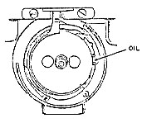
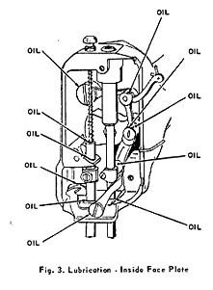 | 