REMOVALS AND REPLACEMENTS
UPRIGHT ARM SHAFT
(GEAR-DRIVEN MACHINES)
CAUTION: do not remove the upright arm shaft from this machine. If this becomes necessary, the machine should be returned to the factory. | The two sets of bevel gears have been lapped together at the factory and should be kept in mesh throughout all removals and replacements.
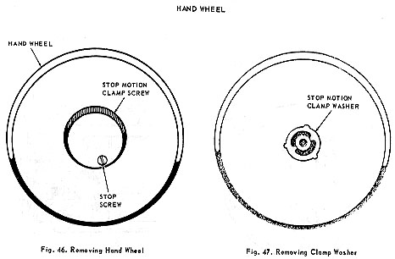
REMOVAL:  1. Loosen motor mounting screw and remove belt.  2. Hold hand wheel and loosen stop motion clamp screw, Fig. 46, by turning toward left.  3. Loosen stop screw, Fig. 46, until end clears stop motion washer. Then turn clamp screw toward left and out of the bushing.  4. Remove stop motion clamp washer, Fig. 47, and slide hand wheel out and off the bushing. | REPLACEMENT:  1. Replace hand wheel on bushing.  2. Replace stop motion clamp washer with lugs inserted in recess provided for them in the bushing.  3. Replace clamp screw and then tighten stop screw  NOTE: if stitching mechanism is not released when stop motion clamp screw is loosened, remove stop motion clamp washer and rotate it 180 degrees.

