REMOVALS AND REPLACEMENTS
FEED LIFTING ROCK SHAFT CONNECTING ROD
REMOVAL  1. Loosen top cover screw and turn cover aside.  2. Remove two cap screws, Fig. 44, and remove connecting rod cap.  3. Remove bottom cover.  4. Remove eccentric screw and nut, Fig. 45, disengaging connecting rod from feed lifting rock shaft  5. Remove connecting rod through bottom of machine. | REPLACEMENT:  1. Insert connecting rod into upright arm through bottom of machine, so that it fits around bottom half of pulley (or gear) hub on eccentric, Fig. 44.  2. Replace connecting rod cap and fasten with cap screws.  3. Replace eccentric screw and nut, Fig. 45, engaging connecting rod to feed lifting rock shaft.  4. Adjust feed dog height.  5. Replace bottom cover and close top cover.
FEED FORKED CONNECTION
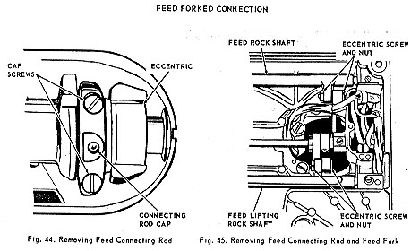
REMOVAL:  1. Remove feed regulator.  2. Open top cover and remove bottom cover.  3. Remove eccentric screw and nut, Fig. 45, disengaging feed forked connection from feed rock shaft.  4. Remove feed forked connection through bottom of machine. | REPLACEMENT:  1. Insert feed forked connection into upright arm through bottom of machine, so that it fits around eccentric, as shown in fig. 44.  2. Replace eccentric screw and nut, fig. 45, engaging feed forked connection to feed rock shaft.  3. Replace feed regulator.  4. Adjust position of feed dog.  5. Replace bottom cover and close top cover.

