REMOVALS AND REPLACEMENTS

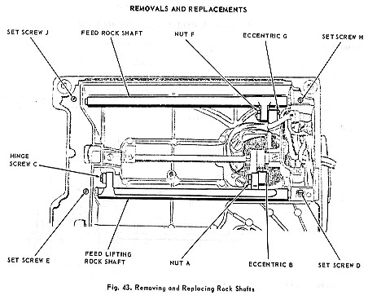
FEED LIFTING ROCK SHAFT  REMOVAL:  1. Remove bottom cover.  2. Remove nut A and eccentric B, Fig. 43, disengaging feed lifting rock shaft from feed connecting rod.  3. Using an offset screw driver, remove hinge screw C, disengaging feed bar.  4. Loosen center set screws D and E, slide the shaft centers aside and remove feed lifting rock shaft.  REPLACEMENT  1. Install feed lifting rock shaft in reverse order of its removal.  2. Adjust feed dog.  3. Replace bottom cover. | FEED ROCK SHAFT ASSEMBLY  REMOVAL:  1. Remove bottom cover  2. Remove nut F and eccentric G, Fig. 43, disengaging feed rock shaft from feed forked connection.  3. Using an offset screw driver, remove hinge screw C, disengaging feed lifting rock shaft.  4. Loosen center set screws H and J, slide the shaft centers aside and remove feed rock shaft with feed bar and feed dog.  REPLACEMENT:  1. Install feed rock shaft with feed bar and feed dog in reverse order of its removal.  2. Replace feed lifting hinge screw.  3. Adjust feed dog.  4. Replace bottom cover.

