REMOVALS AND REPLACEMENTS
ROTATING HOOK SHAFT (BELT DRIVEN MACHINES)
REMOVAL:  Proceed as instructed for gear-driven machines except as follows:  1. Do not disturb wiring.  2. Loosen set screws in hook shaft pulley, Fig. 41, counterbalance and hook assembly. Remove old shaft out through left end of machine. Do not use new shaft as a tool. | REPLACEMENT:  Proceed as instructed for gear-driven machines except as follows:  1. Insert new shaft from the left.  2. Insert shaft through pulley and belt. Place pulley against right end bushing and tighten set screws.
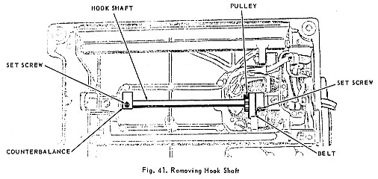

FEED REGULATOR
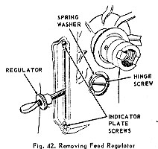 | REMOVAL:  1. Remove hand wheel.  2. Remove stitch indicator plate screws, Fig. 42, regulator hinge screw and spring washer.  3. Remove feed regulator and indicator plate as a unit.  REPLACEMENT:  1. Insert regulator into the machine. Make certain that the roller of feed forked connection rides in the slideway of regulator block.  2. Replace hinge screw and washer. The prongs of the washer should face inward.  3. Replace indicator plate screws.  4. Replace hand wheel.

