REMOVALS AND REPLACEMENTS
Rotating Hook Assembly
REMOVAL:  1. Remove needle, throat plate and bobbin case.  2. Turn machine over on rear side and remove bottom cover.  3. Loosen two set screws, Fig. 39, in hub of hook assembly.  4. Remove assembly from hook shaft.  REPLACEMENT:  1. Replace assembly on hook shaft.  2. Replace needle. | 3. Adjust clearance between hook and needle, and reset timing.  4. Replace bottom cover, bobbin case and throat plate.  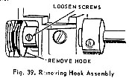
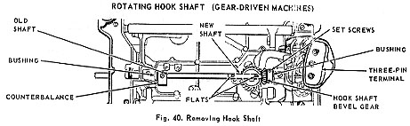
REMOVAL:  1. Remove needle, throat plate, bobbin case and bottom cover.  2. Remove rotating hook assembly, as previously instructed, and bobbin case base.  3. Loosen counterbalance set screw and hook shaft bevel gear set screws. (See Fig. 40).  CAUTION: MARK RELATIVE POSITION OF MATED BEVEL GEARS to insure proper mesh on later assembly.  4. Remove screw holding the three-pin terminal, Fig. 40, and carefully push aside the wiring to expose right end of hook shaft.  5. Using new shaft as a tool, push old shaft out through left end of machine. Make certain that the inserted end of the new shaft presents the flats,Fig. 40, on which the rotary hook set screw and counterbalance set screw, respectively, are to be tightened |  | REPLACEMENT:  1. Replace rotating hook on hook shaft being certain that left end of shaft is flush with face of hook, when hub of hook is against shaft bushing. The set screw in hub, nearest the hook point, should engage flat of shaft. Tighten set screws in hub.  2. Check position marking on hook shaft bevel gear and tighten set screws while gear is against bushing at right end of shaft.  3. Hold counterbalance against bushing and tighten set screw against flat of shaft.  4. Reassemble the bobbin case base in the hook. (In machines using the old style hook, it will be necessary to remove the hook from the shaft.)  5. Check for binding and end play.  6. Replace needle and adjust clearance between hook and needle and reset hook timing.  7. Replace three-pin terminal, bottom cover, bobbin case and throat plate.

