REMOVALS AND REPLACEMENTS
BOBBIN CASE BASE (LATEST STYLE)
REMOVAL:  1. Remove throat plate and bobbin case.  2. Remove gib screw, Fig. 34, and displace gib as shown in fig. 35.  3. Turn bobbin case base so small point on bobbin case base is beneath point of sewing hook as shown in Fig. 35.  4. Remove base by lifting upward and out. | REPLACING:  1. Replace bobbin case base in position as shown in fig. 35. Rotate it slightly until it seats.  2. Return gib to original position and replace screw. 3. Replace throat plate, making certain that the position finger is in notch of position plate under throat plate.
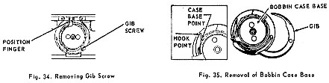
BOBBIN CASE BASE (OLD STYLE)
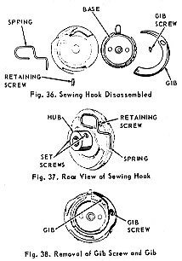 | REMOVAL:  1. Remove throat plate, bobbin case and bottom cover.  2. Loosen two set screws in hub of hook, Fig. 37, and remove hook from hook shaft.  3. Remove retaining screw and spring, Fig. 37, from rear of hook.  4. Remove gib screw and gib, Fig. 38, from front of hook.  5. Lift bobbin case base from face of hook.  REPLACEMENT:  1. Place base in its seat in hook.  2. Replace gib and gib screw on front of hook as shown in Fig. 38.  3. Replace spring and retaining screw on rear of hook as shown in Fig. 37.  4. Replace hook on hook shaft, position in relation to needle and reset time.  5. Replace bottom cover and throat plate.

