REMOVALS AND REPLACEMENTS
NEEDLE THREAD TENSION (continued)
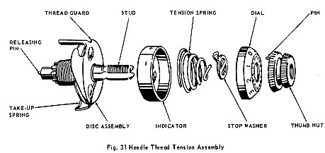
REPLACEMENT:  1. Make certain that releasing pin is in place as shown in Fig. 31.  2. Place tension discs, with convex sides together, on thread guard as shown in Fig. 32.  3. Pass eyelet of take-up spring under thread guard, keeping coils of spring above tension discs as shown in Fig. 32.  4. Align coils of spring with hole in discs and place this assembly on stud as shown in Fig. 33. Tail of thread guard enters hole provided in machine head: Note: Tail of spring, Fig. 33, enters one of the grooves in rear of stud.  5. Replace indicator, open side out, on stud with plus and minus indications at top as shown in Fig. 31.  6. Insert tension spring into indicator and replace stop washer as shown in Fig. 31  7. Place numbered dial on stud with numeral 2 opposite stop washer extension. Press in dial to compress spring. While holding in, replace thumb nut, carefully guiding pin into one of the holes in the dial.  8. Replace entire tension assembly into machine and tighten set screw.  9. Adjust tension. | 