REMOVALS AND REPLACEMENTS
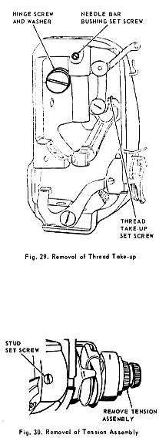 | NEEDLE THREAD TAKE UP  REMOVAL  1. Remove face plate.  2. Remove presser bar and needle bar.  3. Loosen set screw, Fig. 29, and remove needle bar bushing.  4. Remove hinge screw and washer.  5. Turn hand wheel until thread take-up set screw, Fig. 29, is accessible through access hole in rear of machine.  6. Loosen thread take-up set screw and remove take-up linkage  CAUTION: Take-up lever cap screw has a left hand thread. For removal, it must be turned CLOCKWISE.  REPLACEMENT:  1. Replace take-up linkage in reverse order instructed for removal with flat of stud toward thread take-up set screw, Fig. 29.  2. Replace washer, take-up link and hinge screw.  3. Replace needle bar bushing.  4. Replace needle bar and presser bar.  5. Set presser bar height and needle bar height (without timing marks).  6. Set needle bar bushing and replace face plate.
NEEDLE THREAD TENSION
REMOVAL:
1. Turn thumb nut to left until zero (0) on dial reaches indicator line.
2. Loosen stud set screw, Fig. 30, and remove entire assembly from machine.
3. Press in on dial, Fi g. 31, disengage pin in thumb nut from hole in dial.
4. Hold dial in and remove thumb nut.
5. Remove dial, stop washer, tension spring, indicator and tension disc assembly which includes thread guard, two discs and take-up spring.

