TO ELIMINATE END PLAY OR BINDING
OF HOOK DRIVING SHAFT
Binding may be caused by lack of lubrication or foreign material obstructing moving parts. Clean and lubricate.  To eliminate end play or binding in hook driving shaft, loosen counterbalance set screw and bushing set screw, Fig. 26. Position shaft as required to eliminate binding or end play and move bushing against the hook, taking care to maintain correct | clearance between needle and hook. Place counterbalance against bushing and tighten set screw. In gear-driven machines, it may be necessary to loosen set screws in horizontal hook shaft bevel gear while making this adjustment. Then tighten set screws.  Recheck clearance between needle and hook and check the hook timing.

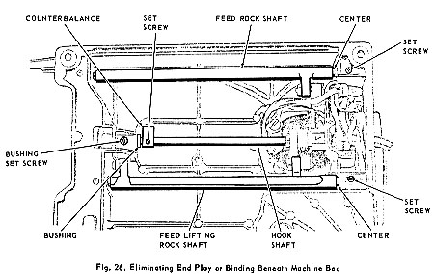

To eliminate end play or binding of feed rock shaft loosen set screw at right end of shaft, Fig. 26, and adjust center shown so that shaft rides snugly but freely, (without left or right movement).  Securely tighten set screw.  To eliminate end play or binding of feed lifting | rock shaft, loosen set screw at right end of shaft, Fig. 26, and adjust center shown as required.  Securely tighten set screw.  Check position of feed dog and adjust as required.

