TO ELIMINATE END PLAY OR BINDING OF HORIZONTAL ARM SHAFT
Should the horizontal arm shaft require adjustment for end play or binding, remove hand wheel as instructed to expose hand wheel bushing.  Loosen set screws, Fig. 24, and move hand wheel bushing slightly away from arm shaft bushing.  Insert a .003 feeler gauge between the two bushings, move hand wheel bushing back against the feeler gauge, and tighten set screw. Replace hand wheel | 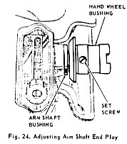
TO ELIMINATE END PLAY OR BINDING OF UPRIGHT ARM SHAFT
(GEAR DRIVEN MODELS)
Open top cover and remove bottom cover. Loosen set screws, fig. 25, in lower vertical bevel gear. Press downward upon upright arm shaft. Set lower vertical bevel gear firmly against lower bushing in casting and securely tighten gear set screw.  Check mesh of upper and lower vertical and horizontal bevel gears to ascertain that they are fully meshed.  To adjust, loosen horizontal bevel gear set screws, fig. 25, and slide gear to position where it is correctly meshed with vertical gear. Then tighten set screws and replace covers.  CAUTION:  Bevel gears must always be kept in mesh at all times. | 