TO ADJUST NEEDLE THREAD TENSION
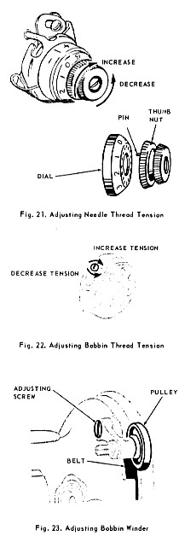 | CHECK:  With machine threaded, lower presser bar to engage tension and turn tension regulator dial to zero (0) position, Fig. 21. Hold thread on both sides of tension regulator and pull back and forth through tension discs. The tension on the thread should be just slightly perceptible, which gradually increases with the turning of the regulator dial to the right.  SETTING:  If the pull on the thread is too strong for minimum tension, press in numbered dial to disengage pin in thumb nut, Fig. 21, from dial. Reset pin in next hole to the left of previous setting. Repeat process until there is no tension on thread. Then advance pin one hole to the right to produce minimum tension at zero (0) position  TO ADJUST BOBBIN THREAD TENSION  CHECK:  Remove threaded bobbin case and bobbin from machine. Hold end of bobbin thread allowing the bobbin case and bobbin to hang free. When tension is correctly adjusted, the bobbin case will descend slowly each time the thread is given a slight "jerk" upward. When using a tensiometer, a bobbin thread tension of approximately 50 grams is sufficient for No. 50-3 mercerized cotton.  SETTING:  Gradually turn tension regulating screw for either increased or decreased tension, as shown in Fig. 22.  TO ADJUST BOBBIN WINDER PRESSURE  CHECK:  The pressure of the bobbin winder pulley against the belt should be just enough to operate the bobbin winder without slippage.  SETTING:  Tighten adjusting screw, Fig. 23, sufficiently to increase pressure of pulley against belt.

