Name:___________________________________________Date:______________
Go to Level 4, Listening. Then, to “Reading Job Want Ads” or directly to the Internet link:
http://www.esl-lab.com/job1.htm
Finding the Right Job Click on Play to hear the sentence.
Write T for true or F for false:
- ______ The editor's job is with a computer hardware company.
2. ______ Candidates for the manager's position should have at least five years experience.
3. ______ Those interested in teaching English should e-mail their resumes.
4. ______ You might have to work overtime in the editor's job.
5. ______ You need at least an Master's Degree to teach at Language Academy.
6. ______ Working hours for the editor's job are from eight thirty to five.
7. ______ Town Bank pays an attractive bonus.
8. ______ People with a background in computers are more qualified for the teaching job.
9. ______ You need no more than two years experience to qualify for the editor's job.
10. _____ You should contact Town Bank by e-mail if you have any questions.

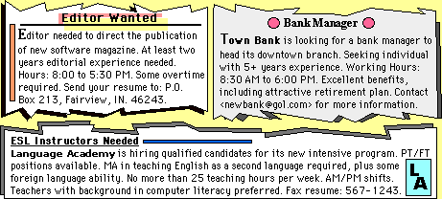

Finding the Right Job Teacher’s Answer Key
1. ( PLAY): The editor's job is with a computer hardware company. (False)
2. ( PLAY): Candidates for the manager's position should have at least five years experience. (True)
3. ( PLAY): Those interested in teaching English should e-mail their resumes. (False)
4. ( PLAY): You might have to work overtime in the editor's job. (True)
5. ( PLAY): You need at least an Master's Degree to teach at Language Academy. (True)
6. ( PLAY): Working hours for the editor's job are from eight thirty to five. (False)
7. ( PLAY): Town Bank pays an attractive bonus. (False)
8. ( PLAY): People with a background in computers are more qualified for the teaching job. (True)
9. ( PLAY): You need no more than two years experience to qualify for the editor's job. (False)
10. ( PLAY): You should contact Town Bank by e-mail if you have any questions.(True)

