- Put on your headphones.

TO GO TO RANDALL'S ESL LISTENING LAB

- In the address box enter: http://www.esl-lab.com
Go to short listening exercises at the bottom of the page.
Click on Directions 2
- Study the map:

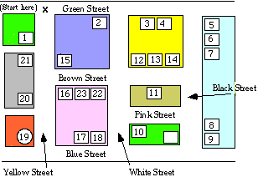

- Click the "Play" button to start the sound. Play as many times as needed.

- Write down each sentence:

- _____________________________________________________________________

- _____________________________________________________________________
- _____________________________________________________________________
- _____________________________________________________________________
- _____________________________________________________________________
  - Click on final score. Then, click on quiz script to check your dictation sentences.
  - For more practice with directions, go to www.mapquest.com (Driving Directions)

