AMERICAN ENGLISH SOUNDS
http://www.uiowa.edu/~acadtech/phonetics/english/frameset.html
© M. Nardecchia

- Go to the Internet.

- At the I.E.L. Web page, click on Student Activities- NEW
Go to ESL, then your level (1,2,3,4, or 5)—Listening –American English sounds

- Click on the top row of buttons to choose a classification of consonants or vowels. The second row will include any appropriate sub-choices.

- Click on: Stop, fricative, affricative, nasal, liquid or glide

Your teacher will circle the choice she wants you to practice.
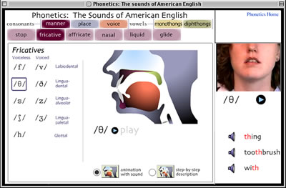
- Click on a sound/ letter in the sound list on the left.
4. Click on the Play button to hear the sound. Repeat the sound.
5. Click on the ⇒ arrow under the woman’s face. For each sound an animation with sound and movie will load. Click on the "step-by-step description" button to show an explanation of the sound articulation. Play the movie by pressing the "play arrow" button.
6. Click on a word to hear it pronounced. Repeat the word.

