Brown Belt: Level 7 Guitar Lessons

The Essence and Importance of Flow

Your Attention Channels

Learning to Play Leads Using the Vector Method
The in mathematics, the definition of "Vector" is "representation of a quantity having both magnitude and direction". In lead playing, a certain quantity and variety of notes are selected and intersect with rhythmic patterns to create the illusion of both magnitude and direction.

How to Listen for the Vector Points
As you study your favorite lead guitarists, learn to listen critically to the passage in the following manner:
- Listen to the first and last notes of the lead first. These are the starting and ending points where you will need to also be.
- Next, listen for the vector, or pivot notes that indicate accents or changes in direction at various times between the starting and ending points on the lead (vector notes very often occur on the strong beat of each measure). Play only the vector notes several times through as you listen to the original artist. This will get you playing the important notes with the important accents in time with the original artist, in much less time than if you just start at the beginning of the lead and plow through to the end.
- Finally, listen for all the connecting notes between the pivot notes, and play along from pivot to pivot note repeatedly until you are quite comfortable before moving on. If you miss one or two of the in-between notes, it still sounds good as long as you keep the time and play cleanly.
We call this approach the "Vector Technique", because it keeps you focused on the important notes and pivotal notes at the end of musical phrases. Kinda like the Karate Kin on Plum Poles, you see here to remind that it's more important to hit the right notes in time to get back home, than to hit every note.
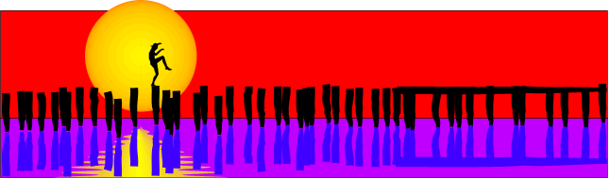

Improve Your Solos with Drones and Pedal Notes
What if you were asked to were asked to play a guitar solo act where you had to play for 10 solid minuteswhile your band goes below for some R & R. Would you be able to keep your audience's interest that long? Would you be able to lead your audience through an experience that they will remember positively? Would your band rejoin you just when the audience is roaring their approval? Or would you flame out and self-destruct becauseyour solos really go nowhere interesting, and you are staring into a sea of yawns?
The difference is in the melody, your understanding of good melody, and how it influences your audience. Good melody is a sense you should over-develop. This will set your original playing apart from thecrowd of lead players, even if your speed and flashy playing only comes in bursts.

How Droning Can Help
Droning is a single note or chord sustained for a very long time. Think of the sound of your car engine droning through the desert highways of Arizona. The next time you are in your car driving down the freeway, try humming in unison with your car engine and wheels. Once you find you are in perfect unison, try humming an original melody that works over the sound of your car. Through trial and error, you will eventually learn what works and what doesn't. You might find that you are more melodic singing than playing guitar. This is because you can focus on the melody without letting technical aspects of an instrument get in the way.
Establishing a drone and playing melody on top is an excellent exercise for guitar as well. I you have an A/B switch with delay effect, play a single note or chord on infinite delay through your A channel, then switch to your B channel to start plucking out melodies, licks, lines and voicings top of the drone you have created.
If you don't have all this equipment, just play with in the key of E or A, using the open string as a drone. Using the remaining strings, work out melodies, licks, lines and voicings that are powerful and compelling.Only re-attack the open string as required to help sustain the droning note so you can play melody over the top.

Pedal Notes
Pedal notes play a role similar to drones, except that the notes are attacked at a constant repeating rate. Pedal notes can be played alternately with notes in the melody, as in Flamenco classics Malaguena and Leyenda de Asturias.

How It Works
You've seen this picture before, but practicing over droning can help you internalize the theory here and make it work from a gut level. The drone note is the tonic, or I note in the scale that you happen to be playing in. By playing notes relative to the tonic, you begin to recognize how notes other than the tonic create a sense of tension or resolve to the tonic or a neighboring note. Don't memorize this picture. Instead, learn to feel the tension and resolve of the notes, and evaluate that pull and direction from an emotionallevel:
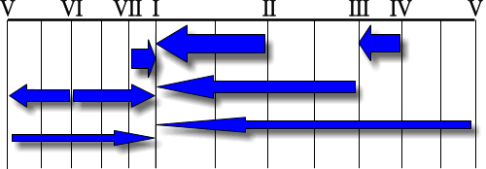
Droning and pedal note techniques are not only fun to play, they forcesyour to play a melody that works with or against the tonic. These exercises will accentuate what works and what doesn't. See, when itsounds good, it sounds really good, and when its bad, it sounds really bad. These exercises will accelerate the rate at which your ear improves.
Some of the best guitar solo acts use a simple but powerful tool to create their own accompaniment while they solo away. Steve Morse, Eric Johnson and Jeff Beck use droning on a loop to accompany their solos very effectively in live shows.

Overtones and Natural Harmonics
This lesson has presents a very cool and unique quality of the guitar as an instrument, namely its your ability to play harmonics on the guitar. Harmonics are produced any time you strike the string of a guitar, but you don't always hear them, because they are naturally occuring overtones, or tones on top of the loud fundamental tone you hear.
To briefly review what you learned in your lessons on major scales and intervals, the fundamental tone is the tone the string produces when the entire length of the open or fretted string vibrates. If you touch the vibrating string lightly at certain points, you dampen the fundamental tone, allowing a softer overtone to be heard. There are an infinite number of points along the string, each producing an overtone, but the loudest and most recognizable overtones correspond to points which divide the vibrating string into equal lengths. The smaller the equal length, the softer the overtone.
As you study this picture, here are some observations that will help you rembember where the loudest natural harmonic points are along any given string:
- Half of the string length is an octave above the fundamental.
- One-quarter string length is two octaves above the fundamental.
- One-eighth string length is three octaves above the fundamental... and so on, ad infinitum.
- One-third string length is a perfect 5th above the first octave.
- One-fifth string length is a major 3rd above the second octave.
- One-sixth string length is a perfect 5th above the second octave.
- One-seventh string length is a minor 7th above the second octave.
Also, in the picture, take note of the similar colors, corresponding to notes in the chromatic scale, as well as the size of the dots, corresponding to the relative strength of the harmonic tone.
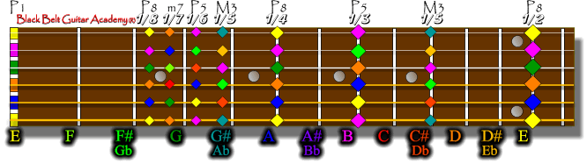
The diagram does not show harmonics above the 12th fret, but they do exist there, in reverse order. Learn the ratios, and play them above the 12th fret as well.

Not All Guitars Created Equally
Some guitars project harmonic overtones more ably than others. If you are using an acoustic top guitar, a thin solid-top model will project louder than a thicker plywood top. If you are using an electric guitar, a hot bridge pickup will detect and amplify harmonics more than a warm jazz neck pickup. Some pickup models are especially built to maximize the effect of harmonics, riding the airwaves on high distortion and volume.

Problems with Natural Harmonic
Natural harmonics are can be very cool, but also problematic if not tamed. Because harmonics arise from touching the string at certain points when vibrating, they can happen accidentally when your left or right hand changes position and touches adjacent strings in those ticklish places. Harmonics can also occur in the form of feedback, when playing loudly, your strings can naturally resonate with its own frequency coming through the amplifier or from other instruments. For this reason, muting with the left and right hand is the antidote to feedback and unwanted harmonic noise. Learn the harmonic points on the guitar also to know what not to play, accidentally.

Who Uses Harmonics?
This list of players is by no means exhaustive, but you might have heard of them: Eddie Van Halen, Steve Morse, Steve Howe, Eric Johnson, Steve Vai, Liona Boyd, Andy Summers, Adrian Legg, John Williams, Andres Segovia, Fernando Sor, Joe Satriani, David Gilmour to name a few. You can add your name to this list of creative virtuosos.

Other Uses for Natural Harmonics
Natural harmonics are a good way to tune a guitar with itself. Playing the same harmonic tone or octave on two vibrating strings at once will allow to you fine tune your guitar. If you cannot get open string tuning and harmonic tuning to sound reasonably in tune on your axe, you might need to take it in to your local luthier for adjustment.

Exercises
Don't try to absorb this picture all at once. Break it down into small digestible pieces, such as:
- Pick a string and learn the harmonics names up and down the string, one string at a time.
- Pick a fret and learn the harmonic names across all strings one fret at a time.
- Pick a note and learn the position of that note everywhere on the fretboard.
The harmonics on the fret board are learned by repetition. Here are a few useful ideas:
- When you do have your guitar with you (and nobody is around to make fun of you) sing the names of the harmonics as you play them. This makes the learning "sticky", and you will internalize it much more quickly than by playing alone.
- Look for and visualize patterns, and play those patterns as you discover them.
- Learn the note locations relative to the inlays (dots) and frets of the guitar neck.
- When you can't have your guitar with you, quiz yourself by drawing the fret board on a piece of paper.
- A little bit every day is better than a lot at once. Don't try to cram for your test. Just make a point of knowing your stuff, and when you realize that you might have some fuzzy areas that need sharpening, just revisit them and you'll see that a little attention will quickly fix them.
Harmonics (Guitar In The Style Of Lenny Breau, Ted Greene, And Ralph Towner) Written by Jamie Findlay. For guitar. Includes instructional book and examples CD. With standard guitar notation, guitar tablature, illustrations and instructional text. Instructional. 16 pages. 9x12 inches. Published by Musicians Institute Press. (HL.695169)
See more info...

Set Management: A Must-Have in Performing

Ongoing Growth: Horizontally and Vertically

Musical Vitamins for Guitar Players

