Red Belt: Level 6 Guitar Lessons

The Essence and Importance of Flow

Scale Modes as Substitutes for Major and Minor
How are Modes Used? Modes are usually used in one of 3 ways:
- When soloing over diatonic major and minor chord progressions
- When soloing over modal progressions
- As substitutes for major and minor scales
This lesson discusses the second and third bullets in the list.

II. Soloing over modal chord progressions
Soloing over modal progressions is a little more fluid sounding than soloing over major or minor progressions, but that is only because with major or minor, we can usually find our way home when we get lost because those progressions are so much more familiar to us.
Modal progressions are the same as harmonic major and minor progressions, except that the starting and ending notes are different. Modal progressions are written in the same key as their parent scale, so the chord names are the same as the major scale, and have the same number of sharps or flats as the parent scale.
With modal progressions, we have to pay a little more attention to the chords in the progression itself, but the basic rules are the same: play the mode that fits the chord in the progression.

III. Scale Modes as substitutes for major and minor scales
The major scale modes fall into one of two categories: Major or Minor. This is dictated by the major or minor 3rd in the scale, which casts a spell over the rest of the notes in the scale, making the whole scale sound major or minor.
Major Scale Modes | Minor Scale Modes
Ionian | Aeolian
Lydian | Dorian
Mixolydian | Phrygian
 | Locrian
Scale modes within the major or minor categories can be called upon to make the piece of music more interesting, or to color the scale for a particular effect.

Ionian Mode
The Ionian scale is the most familiar of all the scales, since we have heard almost daily since birth. It has a happy effect upon us. It is major by virtue of the major 3rd, and the distinguishing degree is the major 7th, which has a strong tendency to pull the ear up a half step to the root or home or key note.
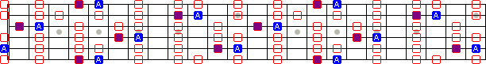
Attributes | Values
Scale Formula | 1-2-3-4-5-6-7
Step Construction | W-W-W-H-W-W-W
Major or Minor | Major
Distinguishing Degree | M7
Good over Chords | M , M7 , M6
Good with Progressions | I-IV-V , II-V-I , I-VI-IV-V , I-III-IV-I , I-IV-I , I-V-I

Lydian Mode
The lydian mode is an airy, floating kind of major scale. The augmented 4th degree makes the listener a little unsure whether the direction of the phrase is towards or away from the tonic.
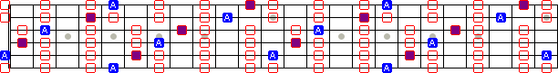
Attributes | Values
Scale Formula | 1-2-3-#4-5-6-7
Step Construction | W-W-W-H-W-W-H
Major or Minor | Major
Distinguishing Degree | #4
Good over Chords | M , M7 , M6
Good with Progressions | I-II , I-II-VII , I-VII , I-III-VII

Mixolydian Mode
The mixolydian mode is a major mode with a slightly funky sound, owing to the dominant or minor 7th degree. Funk and blues players should be very familiar with this scale.
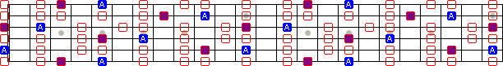
Attributes | Values
Scale Formula | 1-2-3-4-5-6-b7
Step Construction | W-W-H-W-W-H-W
Major or Minor | Major
Distinguishing Degree | m7
Good over Chords | M , 7
Good with Progressions | I-VII , I-VII-IV , I-Vm , I-IV , I-VI-VIIm

Aeolian Mode
The aeolian mode is a staight-forward minor scale. It is the backbone for all minor playing, and the other minor modes are a slight departure from this scale.
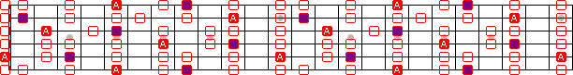
Attributes | Values
Scale Formula | 1-2-b3-4-5-b6-b7
Step Construction | W-H-W-W-H-W-W
Major or Minor | Minor
Distinguishing Degree | m6
Good over Chords | m , m7 , m6
Good with Progressions | Im-bVII-bVI , Im-IVm , Im-Vm , Im-bIII-bVII

Dorian Mode
The Dorian mode is a minor scale whose overall feel and flavor is minor, but it is softened slightly by the use of the major 6th, instead of the minor 6th. It is a favorite scale in the music of Carlos Santana, Jimi Hendrix Stevie Ray Vaughan, to name a few.
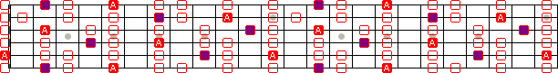
Attributes | Values
Scale Formula | 1-2-b3-4-5-6-b7
Step Construction | W-H-W-W-W-H-W
Major or Minor | Minor
Distinguishing Degree | M6
Good over Chords | m , m7 , m6
Good with Progressions | Im-IV , Im-IIm , Im-bIII-IV , Im-Vm-VI-Im , Im-IIm-bIII-Im

Phrygian Mode
The phrygian mode is a very exotic-sounding minor scale owing to the minor 2nd. You hear this scale often in flamenco music and metal shred music.
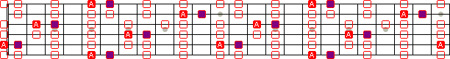
Attributes | Values
Scale Formula | 1-b2-b3-4-5-b6-b7
Step Construction | H-W-W-W-H-W-W
Major or Minor | Minor
Distinguishing Degree | m2
Good over Chords | m , m7
Good with Progressions | Im-bII , Im-bIII-bII , Im-bVIIm , Im-bII-bVIIm

Locrian Mode
The locrian mode is a minor mode with a very eccentric feel. It has both a minor 2nd and a diminished 5th. This is a "surprise" scale that you can use in some phasing to add variety to blues or pentatonic playing.
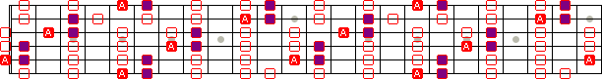
Attributes | Values
Scale Formula | 1-b2-b3-4-b5-b6-b7
Step Construction | H-W-W-H-W-W-W
Major or Minor | Minor
Distinguishing Degree | m2,d5
Good over Chords | o , dim , m7b5
Good with Progressions | Io-bII , Im7b5-IVm7 , Im7b5-bVIIm7

Tom Kolb has been an instructor at Musician's Institute after graduating with honors and receiving Student of the Year in 1989. Tom has played over 4,000 gigs in the US and Europe, and has done copious studio work with major artists, as well as playing in his own band.
The trouble with learning scale modes is that teachers either don't know modes well themselves, or maybe they do, but don't know how to teach them. Tom has taught modes to hundreds of students, and now has a book with a CD that helps you get scale modes into your playing as soon as possible.
Modes For Guitar Written by Tom Kolb. For guitar and voice. Includes instructional book and examples CD. With guitar tablature, standard notation, chord names, guitar chord diagrams, instructional text, introductory text and guitar notation legend. Scales and soloing. 56 pages. 9x12 inches. Published by Musicians Institute. (HL.695555)
See more info...

Your Attention Channels

Red Hot Double Stop Picking
High-octane double-stops fuel hot country and rockabilly solos. This lessons introduces double-stop picking, and gives you the are some ideas for supercharging your leads.
Category: Red Belt: Techniques
Subcategory: Lead
Published on: 17 May 2004

Intro to Major Scale Modes
Major scale modes are simply scales within the major scale. Scale modes created by playing the notes within the parent scale but starting and ending on different notes of the parent scale.
For example: DO - RE - MI - FA - SO - LA - TI - DO represents the major scale which is the parent scale for all the modes.
By shifting the tonality up each of the steps in this scale we get the following:
- DO - RE - MI - FA - SO - LA - TI - DO : Ionian
- RE - MI - FA - SO - LA - TI - DO - RE : Dorian
- MI - FA - SO - LA - TI - DO - RE - MI : Phrygian
- FA - SO - LA - TI - DO - RE - MI - FA : Lydian
- SO - LA - TI - DO - RE - MI - FA - SO : Mixolydian
- LA - TI - DO - RE - MI - FA - SO - LA : Aeolian
- TI - DO - RE - MI - FA - SO - LA - TI : Locrian
Even though each mode uses the exact same notes as all the other modes, we perceive a great difference between them because the intervals are assembled in a different order.
How are Modes Used? Modes are usually used in one of 3 ways:
- When soloing over diatonic major and minor chord progressions
- When soloing over modal progressions
- As substitutes for major and minor scales
This lesson discusses the first bullet:

I. Soloing over diatonic major and minor chord progressions
Each mode in the major scale corresponds to a chord in the major harmonic scale.
Chord Number | Chord Examples in Key of C | Corresponding Scale Mode
I Chord | CM , CM7 , CM6 | C Ionian
II Chord | Dm , Dm7 , Dm6 | D Dorian
III Chord | Em , Em7 | E Phrygian
IV Chord | FM , FM7 , FM6 | F Lydian
V Chord | GM , G7 | G Mixolydian
VI Chord | Am , Am7 , Am6 | A Aeolian
VII Chord | Bo , Bm7b5 | B Locrian
Diatonic chord progressions are built upon harmonic scale for the key in which the song is written. All the notes in all of the chords are common to the major scale in that key, and so the scale selection with the least amount of risk is the scale that fits perfectly over the chord being played.
Let's have a look at each of the modes corresponding to the relative chord in the harmonic scale in the key of C. In the charts below, the white dots are the starting and ending points of each scale. The bright blue dots are the anchor notes, or the root of the C, in this case.

Ionian Mode
The Ionian mode fits exactly over the I chord in the harmonic scale.
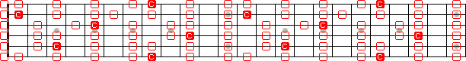

Dorian Mode
The Dorian mode fits exactly over the ii chord in the harmonic scale.
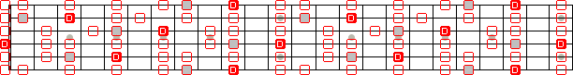

Phrygian Mode
The Phrygian mode fits exactly over the iii chord in the harmonic scale.
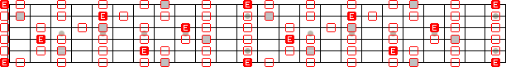

Lydian Mode
The Lydian mode fits exactly over the IV chord in the harmonic scale.
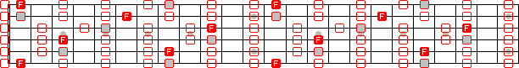

Mixolydian Mode
The Mixolydian mode fits exactly over the V chord in the harmonic scale.
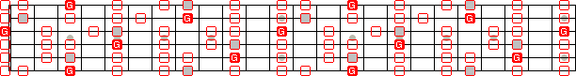

Aeolian Mode
The Aeolian mode fits exactly over the vi chord in the harmonic scale.
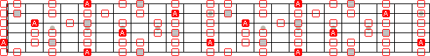

Locrian Mode
The Locrian mode fits exactly over the vii chord in the harmonic scale.
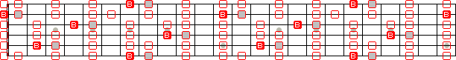
Tom Kolb has been an instructor at Musician's Institute after graduating with honors and receiving Student of the Year in 1989. Tom has played over 4,000 gigs in the US and Europe, and has done copious studio work with major artists, as well as playing in his own band.
The trouble with learning scale modes is that teachers either don't know modes well themselves, or maybe they do, but don't know how to teach them. Tom has taught modes to hundreds of students, and now has a book with a CD that helps you get scale modes into your playing as soon as possible.
Modes For Guitar Written by Tom Kolb. For guitar and voice. Includes instructional book and examples CD. With guitar tablature, standard notation, chord names, guitar chord diagrams, instructional text, introductory text and guitar notation legend. Scales and soloing. 56 pages. 9x12 inches. Published by Musicians Institute. (HL.695555)
See more info...

Reading Music for Guitar: Pegging Notes to Fret board
This graphic will help you visually tie the notes on paper to the notes on your fretboard. The dots on the fretboard are the different notes, and the size of the dot corresponds to the octave in which the note resides.
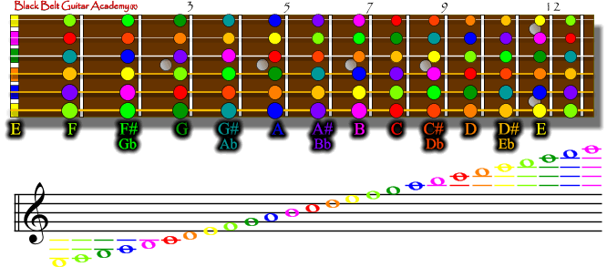

Music Reading for Guitar
Decide now to learn to read standard notation for guitar, and you'll open doors that remain locked to all self-taught players who may spend a lifetime in musical illiteracy. If you think it is a waste of time, it might be because nobody has been able to show you the way to learn.
The very best players all know how to read and write music, because they put the time in to learn how. Steve Vai is particularly emphatic about the importance of learning how to read standard notation, because not all instruments in the band can use tablature. Think of other greats, such as Chet Atkins, George Benson, Steve Morse, who can read and play in real time.
I don't wanna fool ya... you just can't learn to read music by scavenging free lessons, downloading tablature or just picking up a score and staring at it. None of these methods provides the necessary hand, ear, eye training you need to really get comfortable.
This book has all the exercises in the right doses and in the right order that you will need. It is not an overnight skill, but with a few minutes a day, and by the end of the year, you'll be reading as fluently as the pros do:

Alternate Picking
Alternate picking is a right-hand picking technique that is especially useful in bluegrass music, where 16th notes (or 8th notes in double 4 time) are the common currency among flat pickers. Picking up and down alternately keeps time, while the left hand works to fret in time with the right.
Tips to help with alternate picking:
- Hold your pick firmly. Two fingers and a thumb are often favored by the world-class pickers.
- Start Slowly, focusing on accuracy first, and speed later.
- Practice your up-stroke twice as much as the down stroke, since the up pick is generally weaker for most players.
- When you can play accurately at a slower speed, turn up the metronome a notch and practice at the new higher speed.
- Think of your picking hand as the piston in an engine, and your fretting hand is connected by a timing chain to your picking hand. Work at this mental image until you feel your two hands working together at any speed.

Exercises
These riffs are inspired by the great alternate picker in rock 'n roll... Steve Morse. The way to learn alternate picking fast, is to hold your pick firmly, then start slow, forgetting about speed in the beginning. Instead, think precision. When you can do these licks flawlessly at a certain speed, then turn up the speed on your metronome and work up gradually until you are picking along at the speed of Steve. Remember, that sloppy speed doesn't count!
The "^" character in the tabs is a downstroke, because it opens downward. Conversely the character opening upward represents the upstroke.

Cruise Missle
This first lick is from Cruise Missile, and is a great right-hand workout, since the left hand should be comfortable doing almost nothing but chromatic quadruplets. Notice at the end of the even measures there is a quarter note. Your right hand gets a rest for a two counts.
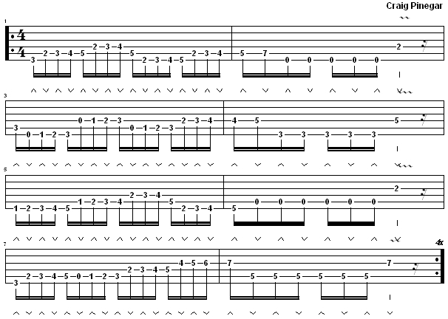
Click on the tab to hear the midi file play. (Windows Media Player works best).

Gentle Flower, Hidden Beast
This second lick is from Gentle Flower, Hidden Beast (this is the beast part of the song). Again, the left hand fingering is straight forward using the 1st and 3rd fingers alternately for most of the lick. Notice the (ghost note) in the 1st and 3rd measures. Even though the left hand swallows the note, the right hand still picks it. In the 4th measure, notice that the right hand misses a couple of up strokes, but still moves up in preparation for the next down strokes.
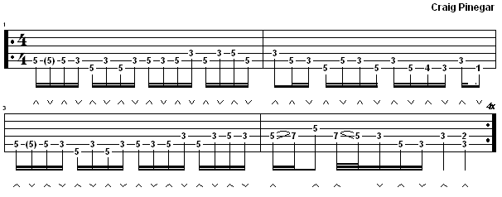
Click on the tab to hear the midi file play. (Windows Media Player works best).

Blackberry Blossom
This third lick is from Blackberry Blossom a classic Bluegrass standard. Even if you don't like country, you really ought to try this one. See if you can keep up with Dan Crary or Mark O'Connor.
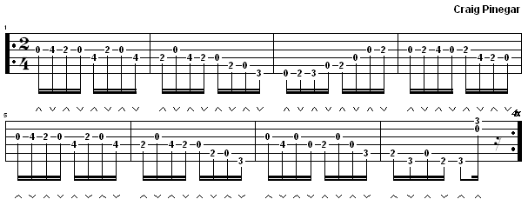
Click on the tab to hear the midi file play. (Windows Media Player works best).

The Never Ending Circle of 5ths
Early in the 18th Century (1728 to be exact), German composer Johann David Heinichen came up with a 12-pointed circle known around the world today as the Circle of 5ths. This very useful tool is at the core of much music theory, because it explains so much with so little space.

Key Aspects of Music Theory Explained by the Circle of 5ths
- Every major key in the circle has a corresponding minor key in the inner circle, known as the relative minor key. The relative major and minor keys are related to each other, because they share the same key signature, as well as the same notes in their scales. The only difference being the emphasis on the notes played make the scales sound either major or minor when played. C/Am are one example.
- Every major key is strongly related to the adjacent major keys in the outer circle by a perfect 5th interval. A perfect 5th up, going clockwise, and a perfect 5th down, going counterclockwise.
- A perfect 5th up from the key note (one click clockwise) is known as the dominant key.
- A perfect 5th down from the key note (one click counterclockwise) is known as the subdominant key.
- Going clockwise, you either lose a flat, or gain a sharp with each point in the circle from where you started.
- Going counterclockwise, you either lose a sharp or gain a flat with each point in the circle from where you started.
- The gain or loss of a single sharp or flat accounts for the adjacent keys in the circle sounding more related than the keys located on points further away from the origin. This is important knowledge to have when composing songs that modulate between keys. (More on modulation in a separate lesson).
- The three sets of keys on the bottom of the circle share the same tones but different key signatures. These are known as enharmonic keys, which literally means that they share the same sound, inspite of their different key signatures. An example of an enharmonic key would be F# and Gb.
- all of the above points are true both in the major keys (outer circle) and the minor keys (inner circle).
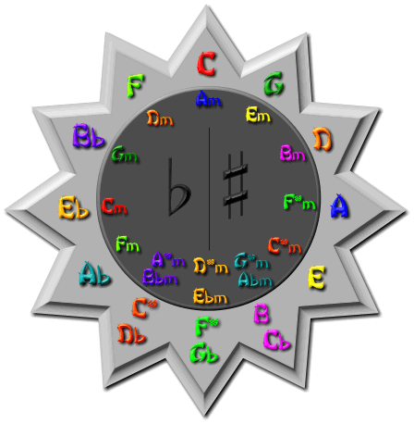
In the table below, spend some time memorizing the key signature on the left, and then on your guitar, play and sing the major and minor scale notes, visually pegging the notes to the staff on the left.
Key Signature | Key Name | Major Scale Notes | Minor Scale Notes
 | C Major  A Minor | C - D - E - F - G - A - B | A - B - C - D - E - F - G
 | G Major  E Minor | G - A - B - C - D - E - F# | E - F# - G - A - B - C - D
 | D Major  B Minor | D - E - F# - G - A - B - C# | B - C# - D - E - F# - G - A
 | A Major  F# Minor | A - B - C# - D - E - F# - G# | F# - G# - A - B - C# - D - E
 | E Major  C# Minor | E - F# - G# - A - B - C# - D# | C# - D# - E - F# - G# - A - B
 | B Major  G# Minor  Cb Major  Ab Minor | B - C# - D# - E - F# - G# - A#  Cb - Db - Eb - Fb - Gb - Ab - Bb | G# - A# - B - C# - D# - E - F#  Ab - Bb - Cb - Db - Eb - Fb - Gb
 | F# Major  D# Minor  Gb Major  Eb Minor | F# - G# - A# - B - C# - D# - E#  Gb - Ab - Bb - Cb - Db - Eb - F | D# - E# - F# - G# - A# - B - C#  Eb - F - Gb - Ab - Bb - Cb - Db
 | C# Major  A# Minor  Db Major  Bb Minor | C# - D# - E# - F# - G# - A# - B#  Db - Eb - F - Gb - Ab - Bb - C | A# - B# - C# - D# - E# - F# - G#  Bb - C - Db - Eb - F - Gb - Ab
 | Ab Major  F Minor | Ab - Bb - C - Db - Eb - F - G | F - G - Ab - Bb - C - Db - Eb
 | Eb Major  C Minor | Eb - F - G - Ab - Bb - C - D | C - D - Eb - F - G - Ab - Bb
 | Bb Major  G Minor | Bb - C - D - Eb - F - G - A | G - A - Bb - C - D - Eb - F
 | F Major  D Minor | F - G - A - Bb - C - D - E | D - E - F - G - A - Bb - C

Limitations of the Circle of 5ths
For all the utility of the Circle of 5ths, there are some very important things that it is not designed to do:
- Once a key is established, the Circle of 5ths does not explain or help analyze chord progressions within a key. (In other words, what chords in the Key of C sound good together).
- When modulating between keys, the Circle of 5ths does not help you find a graceful pivot chord to bridge the jump between keys.
For chord work within a key, or between keys, the Nashville Numbering System works much better (more on this in a separate lesson).

Compound Intervals: Intervals in 2nd Octave
Intervals in the second octave are useful in guitar, because some intervals within the first octave cannot be played with other adjacent intervals in the same octave, because they must be played on the same string. For example, a second and third cannot be played in a chord in the same chord, so one solution is to use open strings, OR to move the second up an octave so that it becomes a ninth.

Interval Name | Number of Half Steps | Consonant / Dissonant | Name of Interval in Second Octave | Other Names, Symbols
�Minor 9th | �13 | �Consonant | �P8 + Minor 2nd | �M9
�Major 9th | �14 | �Dissonant | �P8 + Major 2nd | �M9
�Minor 10th | �15 | �Dissonant | �P8 + Minor 3rd | �m10
�Major 10th | �16 | �Consonant | �P8 + Major 3rd | �M10
�Perfect 11th | �17 | �Consonant | �P8 + Perfect 4th | �P11
�Diminished 12th /  �Augmented 11th | �18 | �Consonant | �P8 + Diminished 5th /  �P8 + Augmented 4th | �d12, b12,  �A11, #11
�Perfect 12th | �19 | �Dissonant | �P8 + Perfect 5th | �P12
�Minor 13th | �20 | �Consonant | �P8 + Minor 6th | �m13
�Major 13th | �21 | �Consonant | �P8 + Major 6th | �M13
�Minor 14th | �22 | �Consonant | �P8 + Minor 7th | �M14
�Major 14th | �23 | �Dissonant | �P8 + Major 7th | �M14
�Perfect 15th | �24 | �Dissonant | �P8 + Perfect Octave | �P15
�

Minor and Major 9th
�

Minor and Major 10th
�

Perfect 11th
�

Augmented 11th / Diminished 12th
�

Perfect 12th
�

Minor and Major 13th
�

Minor and Major 14th
�

Perfect 15th

Intervals: Musical Atoms
When we hear two tones of different pitches, our mind perceives that one tone is higher or lower than the other. This difference in pitch is perceived as distance between the tones. The greater the perceived distance, the larger the interval. We give these intervals names to describe them, and help us understand what is going on musically.
This diagram will show graphically why there is a natural relationship between some tones, and why some tones seem more related to us than others.
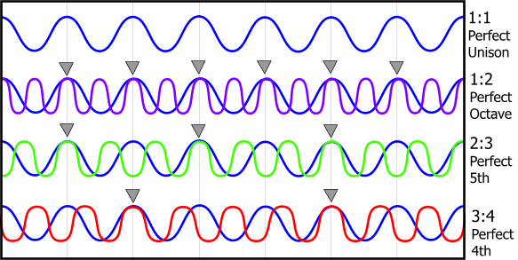
How about a little experiment? Pluck the open A string on your guitar. Now imagine that the vibrations that your string produces through your soundboard, then later in your eardrum could be caught and colored blue. You would have something like the first wave line in the diagram. Any other instrument playing a tone with the same frequency (440 vibrations per second in the case of an A) would be playing in perfect unison with your instrument.
While the open A string is vibrating, pluck an A on the 7th fret of the D string and color it purple. If your guitar is in tune, the upper A will vibrate exactly twice as fast as the lower A. This is like the second set of waves on the diagram. For every peak in the lower frequency, there are precisely two peaks in the upper frequency. You hear an octave, which your mind tells you is the same note... only higher. This is because your brain interprets this simplest of ratios 1:2 as a perfect octave.
Next, pluck the open A string and the D string on the 2nd fret. We already established that the A is blue, so we need the E to be a different color... green. For every 2 peaks in the vibration of the lower tone, there are precisely 3 peaks in the vibration of the upper tone. This ratio of 2:3 is perceived as a perfect 5th interval.
Next, pluck the open A string again, and the open D string. Color the D red, and notice that for every 3 peaks in the vibration of the lower tone there are exactly 4 peaks in the vibration of the upper tone. This 3:4 ratio is perceived as a perfect 4th interval.
Your awesome brain is wired to organize tones at lightning speed, and perceives some tones played together or in series to be related, and while others sound chaotic. Those tones that sound related to each other do so because of simple frequency ratios, as explained above.

Interval Summary

Intervals in the 1st Octave
Interval Name | Number of Half Steps | Frequency Ratio | Consonant / Dissonant | Other Names, Symbols | Inverted Interval Name | Name of Interval in Second Octave
�Perfect Unison | �0 | �1 | �Consonant | �P1 | �Perfect Unison | �Perfect Octave
�Minor 2nd | �1 | �15:16 | �Dissonant | �m2, b2 | �Major 7th | �Minor 9th
�Major 2nd | �2 | �8:9 | �Dissonant | �M2, 2 | �Minor 7th | �Major 9th
�Minor 3rd | �3 | �5:6 | �Consonant | �m3, b3 | �Major 6th | �Minor 10th
�Major 3rd | �4 | �4:5 | �Consonant | �M3, 3 | �Minor 6th | �Major 10th
�Perfect 4th | �5 | �3:4 | �Consonant | �P4 | �Perfect 5th | �Perfect 11th
�Augmented 4th /  �Diminished 5th | �6 | �32:45 | �Dissonant | �d5, b5, A4, #4, Tritone | �Diminished 5th /  �Augmented 4th | �Augmented 11th /  �Diminished 12th
�Perfect 5th | �7 | �2:3 | �Consonant | �P5 | �Perfect 4th | �Perfect 12th
�Minor 6th | �8 | �5:8 | �Consonant | �m6, b6 | �Major 3rd | �Minor 13th
�Major 6th | �9 | �3:5 | �Consonant | �M6, 6 | �Minor 3rd | �Major 13th
�Minor 7th | �10 | �5:9 | �Dissonant | �m7, b7 | �Major 2nd | �Minor 14th
�Major 7th | �11 | �8:15 | �Dissonant | �M7, 7 | �Minor 2nd | �Major 14th
�Perfect Octave | �12 | �1:2 | �Consonant | �P8 | �Perfect Octave | �Perfect 15th
�

Interval Spellings
This chart shows the spelling of all intervals upward and downward from any starting point. This is important to know when composing music, because if you know the name of one note, then by hearing the interval, you will know the name of the next note you hear by ear.
P1 | m2 | M2 | m3 | M3 | P4 | Au/Dm | P5 | m6 | M6 | m7 | M7 | P8
�Ab | �Bbb | �Bb | �Cb | �C | �Db | �D/Ebb | �Eb | �Fb | �F | �Gb | �G | �Ab
�A | �Bb | �B | �C | �C# | �D | �D#/Eb | �E | �F | �F# | �G | �G# | �A
�A# | �B | �B# | �C# | �C## | �D# | �D##/E | �E# | �F# | �F## | �G# | �G## | �A#
�Bb | �Cb | �C | �Db | �D | �Eb | �E/Fb | �F | �Gb | �G | �Ab | �A | �Bb
�B | �C | �C# | �D | �D# | �E | �E#/F | �F# | �G | �G# | �A | �A# | �B
�C | �Db | �D | �Eb | �E | �F | �F#/Gb | �G | �Ab | �A | �Bb | �B | �C
�C# | �D | �D# | �E | �E# | �F# | �F##/G | �G# | �A | �A# | �B | �B# | �C#
�Db | �Ebb | �Eb | �Fb | �F | �Gb | �G/Abb | �Ab | �Bbb | �Bb | �Cb | �C | �Db
�D | �Eb | �E | �F | �F# | �G | �G#/Ab | �A | �Bb | �B | �C | �Db | �D
�D# | �E | �E# | �F# | �G | �G# | �G##/A | �A# | �B | �B# | �C# | �D | �D#
�Eb | �Fb | �F | �Gb | �G | �Ab | �A/Bbb | �Bb | �Cb | �C | �Db | �D | �Eb
�E | �F | �F# | �G | �G# | �A | �A#/Bb | �B | �C | �C# | �D | �D# | �E
�F | �Gb | �G | �Ab | �A | �Bb | �B/Cb | �C | �Db | �D | �Eb | �E | �F
�F# | �G | �G# | �A | �A# | �B | �B#/C | �C# | �D | �D# | �E | �E# | �F#
�Gb | �Abb | �Ab | �A | �Bb | �Cb | �C/Dbb | �Db | �Ebb | �Eb | �Fb | �F | �Gb
�G | �Ab | �A | �Bb | �B | �C | �C#/Db | �D | �Eb | �E | �F | �Gb | �G
�G# | �A | �A# | �B | �B# | �C# | �D##/D | �D# | �E | �E# | �F# | �G | �G#
�

Perfect Intervals
Perfect intervals are the first intervals to master because they are the most familiar to most unseasoned ears. Most people instantly recognize an octave when they hear it.
�

Perfect Unison
The first interval we commit to ear and finger memory is the perfect unison. A perfect unison is the same note played twice. On a guitar, a perfect unison can be played melodically (one note at a time) on the same string or harmonically (two notes at the same time) on different strings.
�

Perfect Octave
The next interval we will commit to ear, mind and finger memory is the perfect octave. The perfect octave is 12 half steps apart on the chromatic scale and 8 notes apart on the major scale. The top note on a perfect octave vibrates exactly twice as fast as the bottom note.
�
A perfect octave is two notes twelve half-steps apart that have the same name. Every time you go up an octave, the strings vibrate twice as fast.
�

Perfect 5ths
The next interval we commit to ear and to finger memory is the Perfect 5th. This interval is present in almost every kind of scale. It is neither major nor minor. It adds stability and power to the chord. When playing two root notes and two fifth notes in two octaves, this chord is called stacked 5ths, and is one of the most powerful chords in rock music.
The ear when it hears a perfect fifth naturally gravitates to the root note, and the fifth adds strength, stability and power to that root.
Church songs sung by medieval monks used perfect 5ths as harmony, because being "perfect" was what godly music was all about. Other kinds of harmony were forbidden in medieval church music because they were seen as pagan at the time.
�

Perfect 4ths
The next interval we commit to ear and finger memory is the Perfect 4th. This interval is the inversion of a perfect 5th, and like the perfect 5th can add power and stability to chords.
It is easy to confuse a perfect 4th with a perfect 5th, because when the ear hears a perfect 4th, it tends to want to hear the top note as the root, then gravitate down a perfect 5th.
Guitar strings are tuned in perfect 4ths from each other. E - A is a perfect 4th, A - D is a perfect 4th, D - G is a perfect 4th, G - B is a major 3rd. It is this tuning that we owe our ability to play so many chords within a 4 or 5-fret span. The EADGBE tuning places the majority of the good-sounding notes in close proximity to each other on different strings so that we can easily reach them with our fingers.
�

Consonant Intervals
Most two-part vocal harmonies in Western music are performed in major and minor thirds. Because they sound familiar to us is why we will commit them next to ear and finger memory.
The tricky part of learning major and minor 3rds is when used together in harmony, sometimes the ear confuses them, and we don't know which is major and minor. We should be able to quickly distinguish between the major and minor 3rd intervals before moving on to other intervals.

Major and minor 3rds
A major 3rd is what makes a major chord sound major, and a minor 3rd is what a minor chord owes its minor sound to.
�

Major and Minor 6ths
The Major 6th has a close relationship with the minor 3rd, because in fact it is the inverse of the minor 3rd. In other words, a major 6th down from a tonic note is an octave below the minor 3rd above the same tonic note. For this reason, the ear is sometimes confused as to whether the 6th is minor or major.
�
In orchestral music, the French Horns often are those playing harmony in major and minor 6ths down from the melody.
�

Dissonant Intervals
These intervals are closest to the tonic note and have greatest propensity to make the ear want to resolve to the tonic note. Dissonant in musical terms means full of energy or tension.

Major and Minor 2nds
These intervals almost always have a strong emotional pull downward to the tonic note. In guitar they are so close to the tonic note on the same string that they lend themselves to trilling (rapid hammering on and pulling off with the left hand) to add heat and energy to the root note.
�

Major and Minor 7ths
These intervals have a strong pull upward to the tonic note, and this is their primary function in music... to lead the listener home. In fact, the 7th interval is what gives the V chord (from the harmonic scale) its dominant characteristic, which tells the listener that the next chord is a I chord (also from the harmonic scale).
�

The Devil's Tone: Augmented 4ths/Diminished 5ths
The Augmented 4th or Diminished 5th interval sounds so strange to our ears, that even though it exists, it is only used sparingly. When it is summoned forth, it can have a surprising or stunning effect on the listener, causing the audience to lose their musical bearing, if only for a moment. It does this because the mind cannot easily perceive which direction they are going relative to home. If dwelt on too long, can erase the notion of home base from the listener's mind. The effect is musical vertigo.

Nashville Numbering System Adapted for Black Belt Guitar
The lion's share of hit music coming out of Nashville (Austin, L.A., New York, Melbourne, Seattle, Liverpoole or anywhere on earth with a radio is diatonic, or based on the major scale. The same is true of most pop, rock, folk, country, bluegrass and classical music.
We should point out a few differences in the notation we use vs. the Nashville Numbering system, but other than the way we write it, the sound and the theory are the same. The Nashville system uses Arabic numbers:(i.e. 1, 2, 3, 4) to number their chords. We use Roman numerals (i.e. I, ii, iii, IV) to number ours. The Nashville system assumes all chord numbers to be major, unless otherwise noted (i.e. min, dim, etc.). We use upper and lower case to indicate the chord type. If the chord type is extended, Nashville writes is as 5(7), and we write it as V7.
Remember that the only difference is the way the chords are written, otherwise, we speak exactly the same language here as in Nashville.
The 7-pointed star is our visual method to help you organize the harmonic scale in each key in a practical and useful way. On the star, you see how each of the points of the star is separated by some kind of 5th. You also see easily the clumping of major and minor chords in blue and red, respectively, and you will later see how to navigate around the points in the star to take your listeners where you want them to go musically.
What you learn right here will be the basis for describing almost all progressions in all your in future lessons pertaining to chord changes. For examble, when we talk about a ii - V - I progression in the key of Am, you'll know exactly what we are talking about, and be able to hear the sound of a ii - V - I in your head, at the same time your fingers know what chords to play. Since you'll also know the viable substitute chords for each position, you'll also have the ability to flavor your renditions in any way you like, without sacrificing musicality.
Later on, the goal is to get the sounds and relative positions of each of these chords in your head, so there is no to need for these pictures as a crutch.

How to Draw Your Own 7-Pointed Star
The best way to internalize this stuff is to draw it for your self. This makes what you learn "sticky", or harder to forget. You will do this 12 times, or once for each key. By then you should have it down pretty well.

Draw the 7 Points and the Yin Yang
Start by drawing a 7-pointed star like so:


Number the Points
Add the Roman numerals I - ii - iii - IV - V - vi - viiº onto each point, starting with the second point on the right, and going counter-clockwise skipping every other point, like so:
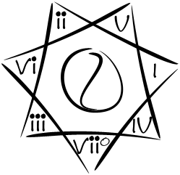
This arranges each chord in the scale so that going clockwise, the adjacent points are a 5th apart. In most cases the chords are a perfect 5th apart, but the IV to the viiº chords are a diminished 5th apart.

Add Key Names and Base Chord Names
Now that we have a generic pointed star, we need to make it key-specific. In the Yang (blue) space, label the name of the major key, and in the yin (red) space, label the name of the parallel minor key. Then, list the names of the base chords of the harmonic scale, corresponding to the key signature in the yin/yang.
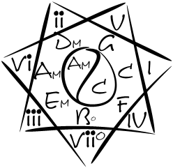

Adding Substitute Chords
In the chart below, we list each of those degrees with a Roman numeral (I - ii - iii - IV - V - vi - viiº), which is a very practical short hand for the chord that should be memorized. Here we will add colors to help in the memorization. Blue is major (1 - 3 - 5), Red is minor (1 - m3 - 5), and Violet is Half-Diminished (1 - m3 - d5).
The table to the right of each star is a list of the common chord name and popular substitutes for each chord. These substitute chords will allow you to inject more color and variety into their playing, while still remaining mostly diatonic. The first row is the name of the triads in the harmonic scale, the second row is the name of the 7th chords, and the third row is some more chords that can be used interchangeably in the I, iii, IV and viiº spots for additional color, without losing the function of the chord.

Key of C Major / A Minor
 | I | ii | iii | IV | V | vi | viiº
 | C | Dm | Em | F | G | Am | Bº7
 | CM7 | Dm7 | Em7 | FM7 | G7 | Am7 | Bº7
 | C6 |  | E7 | F6 |  |  | Bm/5+

Exercises:
Your homework is to construct a table like the one above for each of the 12 keys. Namely, C/Am, Db/Bbm, D/Bm, Eb/Cm, E/C#m, F/Dm, Gb/Ebm, G/Em, Ab/Fm, A/F#m, Bb/Gm, B/G#m. The answers to your homework assignment are on the next page, but we encourage you not to print that page, since it will rob you of the opportunity of constructing it for yourself, which will lengthen the time it takes to learn it and eventually throw it away. A Better way to check your work is to play the chords on your guitar, and if it sounds right... chances are it is right.
There are 3 enharmonic keys (same notes as other keys but use different names), which you can do as extra credit if you would like. These are C#/A#m (same notes as Db/Bbm), F#/D#m (same notes as Gb/Ebm), and Cb/Abm (same notes as B/G#m).

Set Management: A Must-Have in Performing

Ongoing Growth: Horizontally and Vertically

Musical Vitamins for Guitar Players

