Blue Belt: Level 5 Guitar Lessons

The Essence and Importance of Flow

Your Attention Channels

The Four Corners of the Harmonic Landscape
Remember that (except for "My One Chord Song" by Keith Urban) all music moves from chord center to chord center, and most often those chords are most often part of the harmonic scale, but not always. Sometimes as we listen to music using our knowledge of the harmonic scale, the composer throws us a curve ball, and suddenly we hear a chord that does not fit neatly within the harmonic scale. Or the whole landscape of the song changes as the composer moves between keys.
Before going too much further, let's make sure we understand a couple of musical terms:
- Chromatic Chords: Chords borrowed from outside the harmonic scale of a given key to add color, movement, tension or contrast to the progression. (Chroma means color, or from the chromatic scale, rather than the diatonic scale).
- Modulation: Complete change from one key to another during a piece, often using pivot chords to transition between keys.
Using the harmonic scale as the common denominator, all Western music can be placed neatly into four broad categories:
- Songs with chords only from the harmonic scale in a single key
- Songs with chords from the harmonic scale in a single key, and borrowed chords outside the harmonic scale
- Songs that change keys, but use only chords within the harmonic scales of those keys
- Songs that change keys, and borrow chords outside the harmonic scales of those keys

The Four Harmonic Quadrants
Lets explore each of the four categories as four quadrants on a compass.
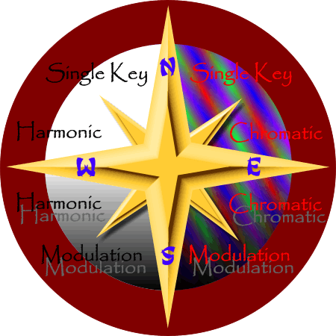

West and East Hemispheres
In the west hemisphere are songs with chords that are strictly within the harmonic scale. These chords may be triads, 7ths, 6ths, or 9ths, diminished or half diminished, or even sustained, but their tonal center fits neatly within the harmonic scale. | In the east hemisphere are songs which borrow chromatic chords, or passing chords between chords of the harmonic scale. Diminished chords and slash chords work extremely well as chromatic passing chords, as well as harmonic chords from other keys.

North and South Hemispheres
In the north hemisphere are songs which are written in one key only. Chromatic chords or not, the key is the same throughout. This is appropriate for simple songs with verses and choruses, and comprises the lion's share of popular music.
In the south hemisphere are songs which have sections, choruses or verses where the key shifts entirely from one to another. This is appropriate for more progressive music, or when the arranger wants to make an ordinary song sound more progressive, or when the composer wants to step the energy of the song up or down by stepping the key up or down.

Some Popular Examples
Single Key, Harmonic | Single Key, Chromatic
- Jingle Bells  - Silent Night  - Jolly Old Saint Nicholas | - It Came Upon a Midnight Clear  - Let It Snow, Let It Snow, Let It Snow  - I Heard the Bells on Christmas Day
Modulation, Harmonic | Modulation, Chromatic
- El Paso (Marty Robbins)  - Rocky Top (Tennessee State Song) | - Mean Mister Mustard (Beatles)  - Oh Darlin' (Beatles)  - Michelle, My Belle (Beatles)

Exercises:
In all the listening you do to songs for the next month, try to listen for the chord progressions, and identify which quadrant that song belongs to. You'll be amazed at your quickened understanding of harmonic progressions. Don't worry if you get confused at first. After a little repetition it will begin to sink in.
Take some of the existing songs you know and add your own chromatic chords by trial and error to find out what works. We will offer some suggestions in other lessons.
Take some more songs you know and step the verse or chorus up or down from where you started. We will offer some suggestions here in later lessons as well. including pivot chords that work well to set up the key change.

Cadences: Musical Punctuation
Have you ever talked to someone who has difficulty making their point? Someone who starts another thought without finishing their first thought? Someone who talks in circles, jumps all over the place, wanders, waffles or otherwise leaves you wondering where it is all going? There are such problems in music too, if you don't understand cadences.
This is a person who does not understand the purpose of phrasing, or punctuation in their speech or writing. In speech and writing, we use phrases, sentences and paragraphs to organize our linear thoughts into a coherent thought train that our audiences can understand. Paragraphs are comprised with at least one sentence, and sentences are comprised of at least one phrase. Phrases, and sentences always end with some kind of punctuation, to let you know that the thought being expressed is either fully complete, or to be continued.
The musical equivalent of punctuation is known as cadence. Cadence is vital in musical thought to indicate to the audience that the phrase is either a complete statement, or to be continued through further listening. Keep in mind that we listeners require most music to go somewhere, and make some kind of point or statement with a definite conclusion.

Two Extreme Examples
To hear illustrate what cadences can do, let's compare two extreme examples:

Yoga Music?
On one end of the spectrum, think of the music you hear when you walk into a meditative establishment, like a trendy Yoga and Health Food Bookstore. You smell the incense. You notice that the music creates a spacious light feeling that lacks borders, boundaries, tension or release, or strong direction. If there is any kind of movement at all, you might describe it as undulating, but certainly not forward moving. The composer creates this kind of ambience by subduing both rhythm and melody, changing chords very slowly by fading them in and out, and most especially by avoiding chord changes that drive to conclusion. In this kind of music, cadences are intentionally avoided, because the composer intends the sense of direction to be lost.

You Ain'tNuttinBut A Hound Dog
On the other end of the spectrum, think of Elvis rocking the house with You Ain'tNuttin' But A Hound-dog.
������������������������I
You ain'tnothin' but a hound dog
���������������I
Cryin' all the time
������������������������IV
You ain'tnothin' but a hound dog
���������������I
Cryin' all the time
����������������V7
Well, you ain't never caught a rabbit
���������������������������I
And you ain't no friend of mine
The gritty lyrics coupled with the I - I - IV - I - V - I progression give the tune strong, predictable harmonic flow towards a definite conclusion in a tight amount of time. The I - I in the first two lines is not a progression, but establish strong tonality. The IV - I in the middle reinforce the first thought with more direction, but ending the tune here would leave us hanging. The V - I progression is the strongest chord change available to put a stamp of finality on the thought. All of these chord progressions were chosen specifically for their powerful effect. These progressions work so well, that thousands of other songs use them.

Types of Cadences
Below are the kinds of common cadences you will need to know. This will help you not only understand and enjoy the music you listen to better, but you will see how you can use these in your own song writing. In all of the examples below, the first two chords set up the tonality, then the last two chords form the cadence.

Authentic Cadence
The cadence is authentic if the tonic chord is preceded by the dominant: V-I.

Perfect Cadence
The perfect cadence contains all tonal means:I-IV (II)-V-I.

Imperfect Cadence
An imperfect cadence ends elsewhere than on the tonic chord: I-V.

Plagal Cadence
The cadence is plagal it the tonic chord is preceded by the subdominant: IV-I.

Deceptive Cadence
A deceptive cadence is on in which the dominant chord is followed by a chord other than the tonic: V-VI.

Exercises
Learn these cadences in all keys, and in several voices. Learn to strum and arpeggiate all these cadences, and use them to connect together or complete musical phrases of your own making.

Harmonic Scale Directional Chord Changes
Remember that all music progresses from chord center to chord center. Chord changes usually happen on the strong beats of a measure, but sometimes more frequently. Understanding how chord changes create a sense of movement is critical to understanding how music works, and how good songwriting is achieved.
Let's briefly touch on the safest formula for good song writing: first, establish tonality (can be done with a measure or two of introduction), second, take the listener on an interesting journey using melody and supporting chord changes to provide forward motion (while respecting that tonality), third, resolve the section or song back to the tonic (end on the tonic with both the melody and harmony). Having said this, you are always free to break these rules, but you should understand them first.
This lesson will show that within a harmonic scale, there are all kinds of possible chord change combinations, but from the perspective of forward motion, there are really only 4 kinds of movements within a harmonic scale you can change to from your present chord:
- You may descend by a 5th
- You may ascend by a 5th (descend by a 4th)
- You may ascend or Descend by a 2nd
- You may ascend or descend by a 3rd
These choices are so grouped to illustrate that not all your choices carry the tune forward as obviously or as strongly as others.
Let's use the Nashville Numbering System to illustrate. The thickness of the arrows around our 7-pointed star gives a sense of the relative strength of the forward motion we perceive by each chord change. We'll take one group at a time.

Descending by 5ths
The first of the harmonic chord changes is the descending 5th. Using our 7-pointed star, a descending 5th chord changes move clockwise, one point at a time. The strongest directional pull is the V - I in the major, and iii - vi in the minor.
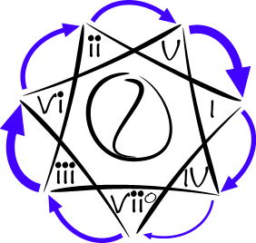
The strength of the motion is really governed by the individual intervals within the changing chords. Reviewing what we learned from our lessons on intervals, note that the strongest motion is when a 7th degree resolves to the root, and when a 4th degree resolves to a major 3rd. In a V - I progression, we have both of these going on at the same time.
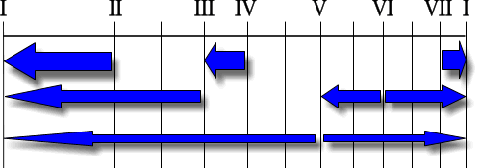
In the key of C, the notes of the V7 chord are G - B - D - F. The notes of the I chord are C - E - G. F resolves to E, which is a 4th to major 3rd degree movement. B resolves to C, which is a 7th to 1st degree movement. G to G is a constant. So strong is this forward motion back to the tonic that it has its own name - "Complete Cadence". (More on cadences later).

Ascending by 5ths (Descending by 4ths)
Going counterclockwise around the 7-pointed star gives us ascending 5ths, which are the same harmonically as descending 4ths. The IV - I and ii - vi progressions are slightly stronger than the rest of the chord changes, but note as a general rule concerning 5ths within the harmonic scale, counterclockwise around the star has weaker motion than clockwise.
Do note, however, that the IV - I progression is also a cadence with its own name - the Plagal Cadence, used commonly as the gentle "amen" at the end of many gospel tunes.
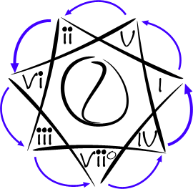

Ascending or Descending by 2nds
Next to the descending 5ths, the kind of harmonic progression with the strongest movement is ascending or descending by a harmonic second. These kind of progressions are simply understood by our musical ear as walking up or down the harmonic scale. Direction is certain, but they do not create the strong sense of anticipation and finality as the descending 5th progressions.
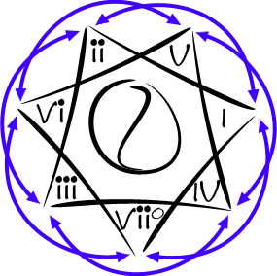

Ascending or Descending by 3rds
The final kind of chord progression in the harmonic scale is the ascending and descending 3rds. Their role is to alternate between the major and minor sides of the same harmonic scale. These are the Yin and Yang of chord progressions. While certainly beautiful, there directional movement is weak, and typically are not used as an ending of a phrase. These progressions may carry the tune for a while, but when the ear is ready to go home, a safe route will be clockwise around the horn back to the tonic.
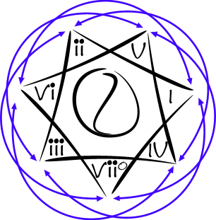

Exercises
Using the Nashville Numbering diagrams of the different keys, try these exercises. Play them all until you really know them by ear. Start in the key of C, then repeat all exercises in all keys.
- Play all the chord pairs of the descending 5th group.
- Play all the chord pairs of the ascending 5th (descending 4th) group.
- Play all the chord pairs of the ascending and descending 2nd group.
- Play all the chord pairs of the ascending and descending 3rd group.
Repeat all these exercises again, this time play them in different chord voicings, including triads, 7th chords substitution chords. Do this in as many chord positions up and down the neck as you can.
Now repeat the exercises again. If you have been strumming, try arpeggiating the chords to get the sound of the chord center in your ear, even when the chord is implied by outlining it with the arppegio, rather than explicitly played as a strummed chord.
Don't rush through the exercises. Rushing will not help you. Take your time, and let your ear and fingers grow comfortable with all the movements. Take special note that the voicing you use does not change the directional movement of the progressions. Also, take special notes of the pairs that stand out to your ear as either familiar, useful, eccentric, or otherwise noteworthy. If later what you learned starts to fade, come back and go through these exercises again.

Intervals: The Essential Building Blocks of All Music
In this lesson lies the secret to emotionally compelling music: Music is not in the notes being played, it is in the relationship between notes being played. Before we can understand what makes melody and harmony work in music, we need to understand the some emotional properties of intervals.
Let's have a look at how different intervals operate on our emotions.
In the Western scale, the I degree is the tonic, root or home base. Once the tonic or root note is established in our minds, our brain automatically compares all other tones of the scale to the tonic, and tells us that we are either moving away from or towards home. Moving away from home produces a sense of interest, excitement, or tension. Returning home after going away produces a sense of rest, resolution, or release. Music holds our our interest as long as there is a sense of motion away from home, with the the promise that we will eventually arrive back home again.
The arrows in this diagram illustrate how intervals in the major scale behave like rubber bands pulling on our emotions. The thicker arrows pull harder toward the arrowhead than the thinner lines in the following manner:
- The I degree has no pull whatsoever. It is home base, which feels good when you come back to it, but after feeling safe for too long we soon feel bored, and long to venture out again.
- The II degree has a strong pull toward the I degree, so much so that it gives a suspended sensation.
- The III degree also has a pull toward the I degree, but slightly less than the II.
- The IV degree has a hard pull toward the III degree, and is also gives a suspended feeling until we arrive again at the III degree.
- The V degree is not exactly half way between the lower and upper I degree, but it sounds like it is. There is a weak pull up or down to the I degree on either end of the scale.
- The VI degree has a moderate pull up to the I degree, or down to the V degree.
- The VII degree has a sharp pull towards the upper I degree in a scale. This gives the VII a strong leading characteristic.

Here is another way to look at the gravitational nature of the tonic I degree on the other degrees in the scale.
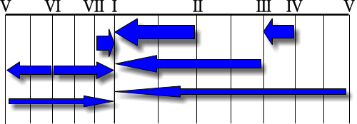
Learning how intervals effect us emotionally helps your ability to write emotionally compelling melodies, and harmonies, or to alter an existing tune for an emotional wallop.
Intervals can't be mastered overnight. In learning intervals thoroughly, the ear and fingers require many repetitions and exposure to intervals in many musical circumstances to really become cultured. It's best to take intervals in small daily doses, at times when your ear is relaxed. Five minutes a day in the morning before diving into other practice routines is probably sufficient.

Harmonic Scale Chords for All Major Keys
This page has all the base chords and a few of the most popular substitute chords you can use in the harmonic scale. Please use this to check your answers to the previous lesson's exercise, and commit now to learn this stuff well.
You know you have learned it well when:
- You can play all the base chords in the harmonic scale, up and down
- You can play any chord by knowing only the key signature and the number of the chord
- Once you establish the tonality of a song you hear, you instantly know the chord number you are hearing
- When playing a song, you know what subsitute chords you can choose from to add flavor, without sacrificing musicality
- When listening to music and you hear a substitute chord, you still recognize the chord number.

Key of C Major / A Minor
 | I | ii | iii | IV | V | vi | viiº
 | C | Dm | Em | F | G | Am | Bº7
 | CM7 | Dm7 | Em7 | FM7 | G7 | Am7 | Bº7
 | C6 |  | E7 | F6 |  |  | Bm/5+

Key of Db Major / Bb Minor
 | I | ii | iii | IV | V | vi | viiº
 | Db | Ebm | Fm | Gb | Ab | Bbm | Cº
 | DbM7 | Ebm7 | Fm7 | GbM7 | Ab7 | Bbm7 | Cº7
 | Db6 |  | F7 | Gb6 |  |  | Cm/5+

Key of D Major / B Minor
 | I | ii | iii | IV | V | vi | viiº
 | D | Em | F#m | G | A | Bm | C#º
 | DM7 | Em7 | F#m7 | GM7 | A7 | Bm7 | C#º7
 | D6 |  | F#7 | G6 |  |  | C#m/5+

Key of Eb Major / C Minor
 | I | ii | iii | IV | V | vi | viiº
 | Eb | Fm | Gm | Ab | Bb | Cm | Dº
 | EbM7 | Fm7 | Gm7 | AbM7 | Bb7 | Cm7 | Dº7
 | Eb6 |  | G7 | Ab6 |  |  | Dm/5+

Key of E Major / C# Minor
 | I | ii | iii | IV | V | vi | viiº
 | E | F#m | G#m | A | B | C#m | D#º
 | EM7 | F#m7 | G#m7 | AM7 | B7 | C#m7 | D#º7
 | E6 |  | G#7 | A6 |  |  | D#m/5+

Key of F Major / D Minor
 | I | ii | iii | IV | V | vi | viiº
 | F | Gm | Am | Bb | C | Dm | Eº
 | FM7 | Gm7 | Am7 | BbM7 | C7 | Dm7 | E#º7
 | F6 |  | A7 | Bb6 |  |  | E#m/5+

Key of Gb Major / Eb Minor
 | I | ii | iii | IV | V | vi | viiº
 | Gb | Abm | Bbm | Cb | Db | Ebm | Fº
 | GbM7 | Abm7 | Bbm7 | CbM7 | Db7 | Ebm7 | Fº7
 | Gb6 |  | Bb7 | Cb6 |  |  | Fm/5+

Key of G Major / E Minor
 | I | ii | iii | IV | V | vi | viiº
 | G | Am | Bm | C | D | Em | F#º
 | GM7 | Am7 | Bm7 | CM7 | º7 | Em7 | F#º7
 | G6 |  | B7 | C6 |  |  | F#m/5+

Key of Ab Major / F Minor
 | I | ii | iii | IV | V | vi | viiº
 | Ab | Bbm | Cm | Db | Eb | Fm | Gº
 | AbM7 | Bbm7 | Cm7 | DbM7 | Eb7 | Fm7 | Gº7
 | Ab6 |  | C7 | Db6 |  |  | Gm/5+

Key of A Major / F# Minor
 | I | ii | iii | IV | V | vi | viiº
 | A | Bm | C#m | D | E | F#m | G#º
 | AM7 | Bm7 | C#m7 | DM7 | E7 | F#m7 | G#º7
 | A6 |  | C#7 | D6 |  |  | G#m/5+

Key of Bb / G Minor
 | I | ii | iii | IV | V | vi | viiº
 | Bb | Cm | Dm | Eb | F | Gm | Aº
 | BbM7 | Cm7 | Dm7 | EbM7 | F7 | Gm7 | Aº7
 | Bb6 |  | º7 | Eb6 |  |  | Am/5+

Key of B / G# Minor
 | I | ii | iii | IV | V | vi | viiº
 | B | C#m | D#m | E | F# | G#m | A#º
 | BM7 | C#m7 | D#m7 | EM7 | F#7 | G#m7 | A#º7
 | B6 |  | D#7 | E6 |  |  | A#m/5+
We will take this opportunity to mention briefly that the Nashville Numbering System will help you recognize and play chords in the diatonic scale, but what if you hear a chord that does not fit in the harmonic scale, or what if the key changes in the middle of the song? We will address this more in depth in future lessons, but the short answer is this: When a musician borrows a chord from outside the scale, (and if they know what they are doing, by not totally losing the rest of us), then we call that a chromatic chord. Chromatic chords are used to add color. If this is the case, we note the chromatic chord, and move on with the rest of the music that remains within the safe harbor of the harmonic scale. If the key changes entirely, we can simply take the two stars from above belonging to each key, and chain them together.

Basic Theory of Harmonic Scale Progressions
In prior chord lessons, you have learned chords by their name, shape, position. You need to know this before you progress any further, because you'll need to know chords by name, and make your own choices whether to play the chords with a capo, use bar chords or inversions, or a combination of all three. In the next few lessons, you'll learn how to connect chords together the way the pros do.
If you don't feel you are solid on the chords learned in earlier lessons, stop now and go back until you are comfortable recognizing and playing all your open chords, bar chords, and inverted chords. Here we will introduce the diminished chord, as it is important in rounding out the harmonic scale. Only the diminished chord should be new to you at this point.

Harmonic Scale
The harmonic scale is a series of seven chords, all of which have notes in the major scale of some key. Because all of the notes belong to the same scale, they naturally sound related, but because each of the chords use different notes in the scale, each has its on characteristics which relate to its position in the scale.
While the harmonic scale played up or down just sounds like a scale with harmony, it is barely musical musical, because it lacks form, and other musical elements that make it interesting. But when you start to take the chords that make up the harmonic scale and rearrange them over time and add melody, an amazing variety of music begins to unfold. Virtually ALL Western music is rooted in this scale, or some variation of it, so now is the time to pay attention. This is where the the hands, the mind and the ear begin to function as an integrated unit.

The Harmonic Scale Using Triads
A Triad is just three notes stacked on top of each other separated by an interval of major or minor 3rds. When you play the major scale in the key of C using triads instead of individual notes, you get the most basic harmonic scale. It looks and sounds like this:
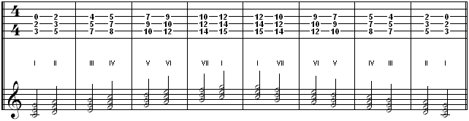

The Harmonic Scale Using 7th Chords
A 7th chord just stacks an additional 3rd on top of the existing triad. The harmonic scale with 7th chords looks and sounds like this:
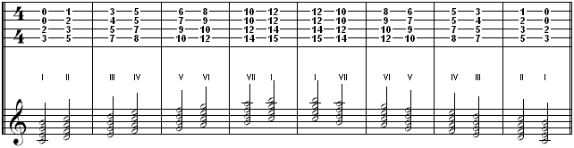
Most of the chords in the above charts are not very guitar-friendly, but they are given to illustrate the principle of stacked thirds. Try playing them as in the charts as an exercise, but in practice, there are more guitar-friendly fingerings, as you have already learned.

The Harmonic Scale Using 2nd Inversion Triads
Played in 2nd Inversion, the harmonic scale looks like this:
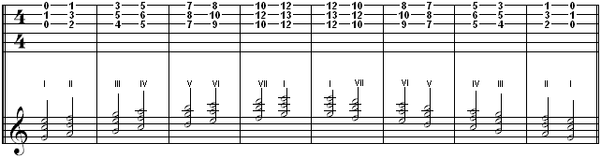

The Harmonic Scale Using 1st Inversion Triads
Played in 1st Inversion, the harmonic scale looks like this:

The Harmonic Scale Using Open Chords
The above examples had you playing all the chords in the scale by moving your hand up and down the neck. But there are many occasions where playing all open chords is more appropriate. Played in Open Chord positions, you can use a capo to raise or lower the key being played in. Using open chords, the harmonic scale looks like this: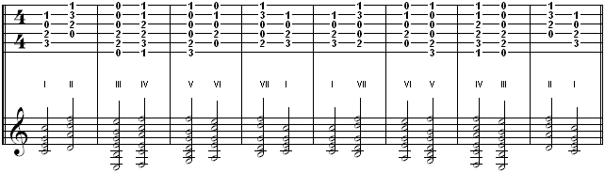

Set Management: A Must-Have in Performing

Ear Training: What? How? Why?

Why Ear Training?
Listening and composing are Siamese twins of a sort. Every time you listen, you form an impression about things going in the music that you personally like and want to make it your own, and you find it coming out in your playing. The more you understand what you are hearing, the more readily you recognize it when you hear it, then you can categorize it in your own mind, then retrieve it later when needed.

A Practical Definition
A practical definition of ear training is: training your mind to understand what your ear hears. Given this definition, is not so daunting or tedious to learn to listen for what is going on in the music you love.

Structuring Your Own Ear Training Program
Not all ear training programs are created equal. You only need to learn what is useful and practical for the kind of music you want to listen to and play, so let that music be your guide. Now, as you listen to the music you love, try to describe musically what is going on in terms that you or another musician can understand. If some area confounds you, or you can't quite sort out what is happening, then you know you need ear training work in that area.

Essential Elements of Ear Training
Here are some essential elements to learn to recognize by ear:
- Perfect Pitch Tone Identification (name that note)
- Perfect Pitch Aural Recall (sing a note without a queue)
- Interval Recognition (name that interval up AND down, melodically. Also harmonically)
- Chord Decomposing (hearing the individual tones in a chord)
- Chord Type Recognition (name that chord by its sound color alone)
- Melodic Scale Degree Recognition (1, b3, 4, 5)
- Harmonic Scale Degree Recognition (I, II, IV, III)
- Cadence Recognition (where in the song are we?)
- Speed Recognition (all of the above)
- Tempo or Meter Recognition (how fast is that?)
- Rhythm or Beat Recognition (salsa, reggae, 4/4, shuffle)
If any of these areas is particularly hard for you to discern or describe, then you may need to sharpen your ear or your theory or both. There are good software and audio products available to drill you initially, but don't become dependent on them. After you understand the terms and concepts that should be trained into your ear, the best ear training is done on your own instrument, and by listening to music and drilling yourself.
Remember that the most important goal of ear training is to learn of these elements by recognition or intuition alone, without too much mental processing. Like learning a new language, this is a long process, and is best learned by small doses every day over time, rather than cramming for some test.

Musical Vitamins for Guitar Players

